SMT. CHANDIBAI HIMATHMAL MANSUKHANI COLLEGE OF ARTS, SCIENCE & COMMERCE
ULHASNAGAR – 421003
(An Institute Under University of Mumbai, Mumbai – 400001)



A Project Documentation on

“IOT Based Ultrasonic Navigation System For Blind People”

submitted in fulfillment of the requirement for the award of the
degree of
BACHELOR OF SCIENCE
in
COMPUTER SCIENCE
Submitted By
Dhurat Jaydeep Dinesh
(2018016401691167)
under the guidance of
Prof. Lata Bhatia
Assistant Professor
Department of Computer Science
Ulhasnagar – 03
2020 – 21

SMT. CHANDIBAI HIMATHMAL MANSUKHANI COLLEGE OF ARTS, SCIENCE & COMMERCE
ULHASNAGAR – 421003

DEAPRTMENT OF COMPUTER SCIENCE

CERTIFICATE
Certified that the project work entitled “IOT Based Ultrasonic Navigation System For Blind People” is a work carried out by Dhurat Jaydeep Dinesh (2018016401691167) in the fulfillment of the award of degree Bachelor of Science in Computer Science from Smt. Chandibai Himathmal Mansukhani College, an institute under university of Mumbai, Mumbai during the academic year 2020-21.
It is certified that all corrections/suggestions indicated for internal assessment have been incorporated in the report submitted to a guide of the project.
The project documentation has been approved as it satisfies the academic requirements in aspect of project work prescribed for the Bachelor of Computer Science degree.

Ms. Lata Bhatia Head of the Department Principal
Assistant Professor Dept. of Computer Science Smt. CHM COLLEGE
Dept. of Computer Science Ulhasnagar – 421003 Ulhasnagar - 421003
Ulhasnagar - 421003

External Viva: Signature with date
Names of the Examiners:
1)
2)

ACKNOWLEDGEMENT

I offer humble pranams at the lotus feet of His Holiness, Principal K. M. Kundnani, Founder President, The Hyderabad (Sind) National Collegiate Board, for bestowing upon their blessings.
I deem it as a privilege to thank Principal Dr. Manju Lalwani Pathak, for fostering an excellent academic environment in this institution, which made this endeavor fruitful.
I would like to express our sincere gratitude to Mrs. Ritika Sachdev, Professor and Head, Department of Computer Science, C.H.M. College, Ulhasnagar - 03 for her encouragement and valuable suggestions.
I thank our guide Ms. Lata Bhatia, Assistant Professor, Department of Computer Science, C.H.M. College, Ulhasnagar - 03 for the valuable guidance, advice and encouragement.

I thank non-teaching staff members of Department of Computer Science for their support during this project work.

Above all, we would like to thank our parents for their support all along.

Dhurat Jaydeep Dinesh
(2018016401691167)

Abstract

Blindness is a state of lacking the visual perception due to physiological or neurological factors. The partial blindness represents the lack of integration in the growth of the optic nerve or visual center of the eye and total blindness is the full absence of the visual light perception. Imagine walking into an unfamiliar place. One has to ask for guidance in order to reach to the destination.
But what if the person is visually impaired!! Person has to completely depend on other people to reach destination. Generally, we observe that white cane is the best friend of visually impaired person. But many a times this cane is not useful. In an unfamiliar surrounding visually impaired person might get confused.
So this restricts their mobility. This makes them dependent on others. Regardless of the tool used the factor that most determines a person's mobility is the use of essential personal skills. Total blindness is the complete lack of form and visual light perception and is clinically recorded as NLP, an abbreviation as “no light perception”.
Blindness is frequently used to describe severe visual impairment with residual vision. Those described as having only light perception have no more sight than the ability to tell light from dark and the general direction of a light source.
The system has been developed using both the hardware and software implementations.

Contents
Abstract
Contents
List of Figures
List of Tables
- Introduction
  - Objective and Motivation of the Project
  - Organization of the report
- Literature Survey
  - Previous Work on Smart Stick
  - Previous Work on Other Systems
- System Overview
  - Hardware Tools
- System Hardware
  - Ultrasonic Sensor
  - Technology Used by Hardware Used
5 System Software
5.1 Technology Used by Software Tools
6 Results
6.1 Code Snippet & Snapshots of Project Work, Progress reports
7 Conclusion and Future work
Bibliography

Chapter 1
Introduction
In our life we meet many disable people, some of them are partially and some are completely disable. The partially impaired people like dumb, and blind manages their life with difficulties and feel separated from others.
Therefore, communication plays a major role and make them feel better and help them to indulge in an activity where they can see themselves as an independent person in public areas.
This will help them in setting up correspondence between Blind/Dumb and the outside world.

Many techniques have to evolved in past twenty years to help visually challenged people.
The new technology that is helping them, although has many features and applications but it is not economical and so people are spending lot of money on it.
The glove that I have made is most cheapest ever possible by using raspberry-pi module and simple way to alert them about the surrounding objects which would be in their way of walking.
When we keep that on we are flexible to move our hands and so we could detect objects in all directions which are in 100 cm of our range. The wearable material gives a visually challenged person to walk freely without anyone's help. The system detects objects in 100 cm range and gives feedback by creating an alarming sound and also vibrating our hand and by this he is alerted from encountering the objects.

  - Objective and Motivation of the Project
The aim of this system is to build an automatic and convenient system to protect the interests of the public by countering the inconvenience struggled by visually impaired or blind individuals. The main purpose of the system is to implement IoT based product for the user, which in turn reduces struggle for their day to day life of the blind persons.

  - Organization of the report
Chapter 2 deals with the literature survey. The block diagram of the system is explained in Chapter 3, giving an overall view of the techniques used in the system. Chapter 4 deals with System hardware and Chapter 5 with system software and flowcharts. Chapter 6 contains result which is explained through snapshots and quantity analysis. Chapter 7 contains conclusion and scope for future work.
Chapter 2
Literature Survey
Blind people facing many challenges moving indoor or outdoor. Over 285 million people are visually impaired worldwide: 39 million of them being blind and 246 million have low vision. About 90 percent of the world’s visually impaired live in developing countries such as India, Bangladesh, Pakistan etc. The blind traveler should depend on any other guide like blind cane, people information, trained dogs, and etc. Blind people need some support to feel safe while moving. The survey of the system which is proposed to help those people who are blind or partially visually impaired.

Blind people may lose intention and have a higher risk of falling but people need to move whether at home, at work or addressing meeting. Most of blind people depend on other human for movement and environmental sensitivity. The impairment is not fixable, even though the employment of glasses, contact lenses or in extreme cases, surgical operation. The incapacity is generally caused by diabetes, macular degeneration, traumatic injuries, infection and eye disease. Alternative causes include blocked blood vessels, complications of premature birth, complication of eye surgery, stroke and tumors. Here square measure several early signs of blindness such a discomfort and weary eyes, foreign body sensation, and pain. Patients could experience discharge from the eyes. World Health Organization has calculable that regarding 285 million individuals worldwide square measure visually impaired; during which 39 million are blind while another 246 million have an occasional vision. The number of people stricken by loss of sight is increasing dramatically. The Royal National Institute of Blind individuals have foretold that by 2020, the amount of visually impaired in worldwide are going to be over two million people.

Blind individual’s expertise difficulties once travelling to their intended destination. One in every of the larger obstacles is to notice foreign objects across their walking path. With relation to Mau et al., roughly 90th of the blind population is unable to travel alone. 3% of them square measure addicted to their pet whereas the remaining seven-membered uses the white cane. Even with the white cane, their quality is still limited; each indoors and out of doors.
2.1 Previous work on smart stick
Blind people who suffer from a severe reduction in vision that cannot be corrected with conventional means, such as refractive correction or medication and reduces a person’s ability to function at certain or all tasks.
The main disadvantage of the smart stick that might be sometimes a smart stick can fail to work if any hard and solid obstacle comes in its way. And eventually this will lead to make some type of damage to the stick which can be very bad as in perspective of blind people in the mid-way of traveling or walking.

Mobility for blind and elderly people is a problem as they have to face many difficulties in their day to day life.
2.2 Previous work on other systems
Previous work on the other systems includes the traditional methods that the blind people using since decades and this traditional methods or solution is not capable for solving their problems as this outdated system has some kind of disadvantages and cons regarding its daily use.

WHITE CANE:
A white cane is a device used by many people who are blind or visually impaired. A white cane primarily allows its user to scan their surroundings for obstacles or orientation marks, but is also helpful for onlookers in identifying the user as blind or visually impaired and taking appropriate care. The latter is the reason for the cane's white color, which in many jurisdictions is mandatory.
Blind people have used canes as mobility tools for centuries, but it was not until after World War I that the white cane was introduced.
In 1921 James Biggs, a photographer from Bristol who became blind after an accident and was uncomfortable with the amount of traffic around his home, painted his walking stick white to be more easily visible.

The white cane is commonly accepted as a "symbol of blindness", different countries still have different rules concerning what constitutes a "cane for the blind".
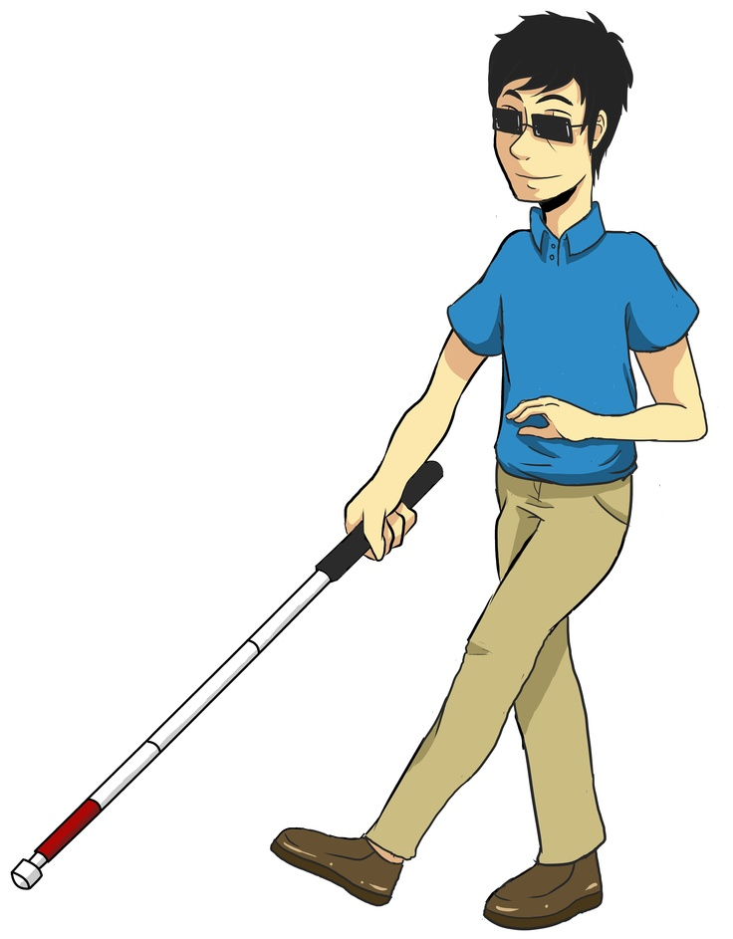
However, the white cane is more than just a tool. It is a symbol of independence, that allows individuals with vision impairments to travel from one place to another, safely and independently.
The white cane is a mobility tool used by people who are blind or who have low vision to get about independently. The working of a white cane is all about the person holds the cane in their dominant hand, roughly centered in front of the body, and the cane is swept from left to right in pattern about shoulder-width of the person.
The white cane used by blind individual should be of about at least 2-3 feet according to height of the individual.

The correct cane technique, which will provide maximum protection and information as follows:
- Hold the cane with your hand centered in front of your body.
- Move the cane with wrist/finger movement only, with your arm remaining skill.
- Move the cane tip in arc that is about an inch wider than your body.
- Move the cane in rhythm with your feet, with the cane tip always being on the opposite side of your forward foot.

- The cane tip either slides along the ground (“constant-contact technique”) or touches the ground at each end of the arc and remains no more than an inch above the ground (“touch technique”).

There are few variants of white canes which visually impaired peoples using till the date:

Long cane:

Designed primarily as a mobility tool used to detect objects in the path of a user. Cane length depends upon the height of a user, and traditionally extends from the floor to the user's sternum. It is the most well-known variant, though some organizations favor the use of much longer canes.
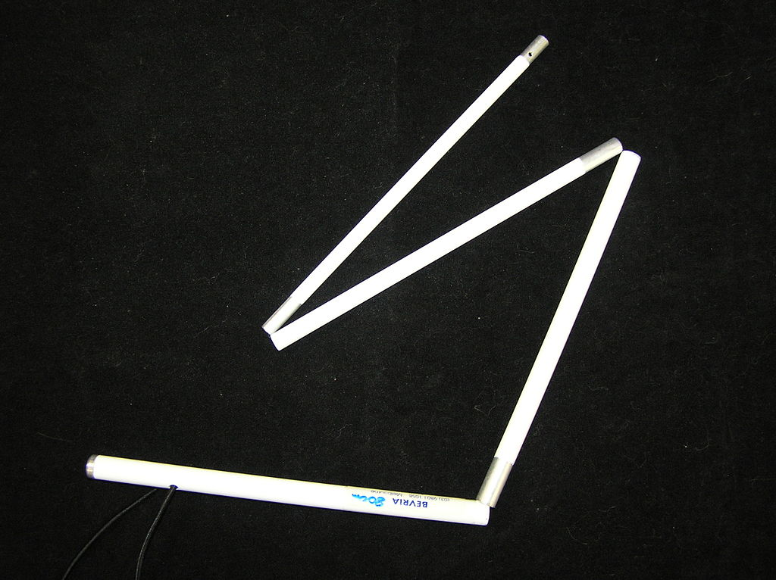

Guide cane:
A shorter cane, generally extending from the floor to the user's waist, with more limited potential as a mobility device. It is used to scan for kerns and steps. The guide cane can also be used diagonally across the body for protection, warning the user of obstacles immediately ahead.
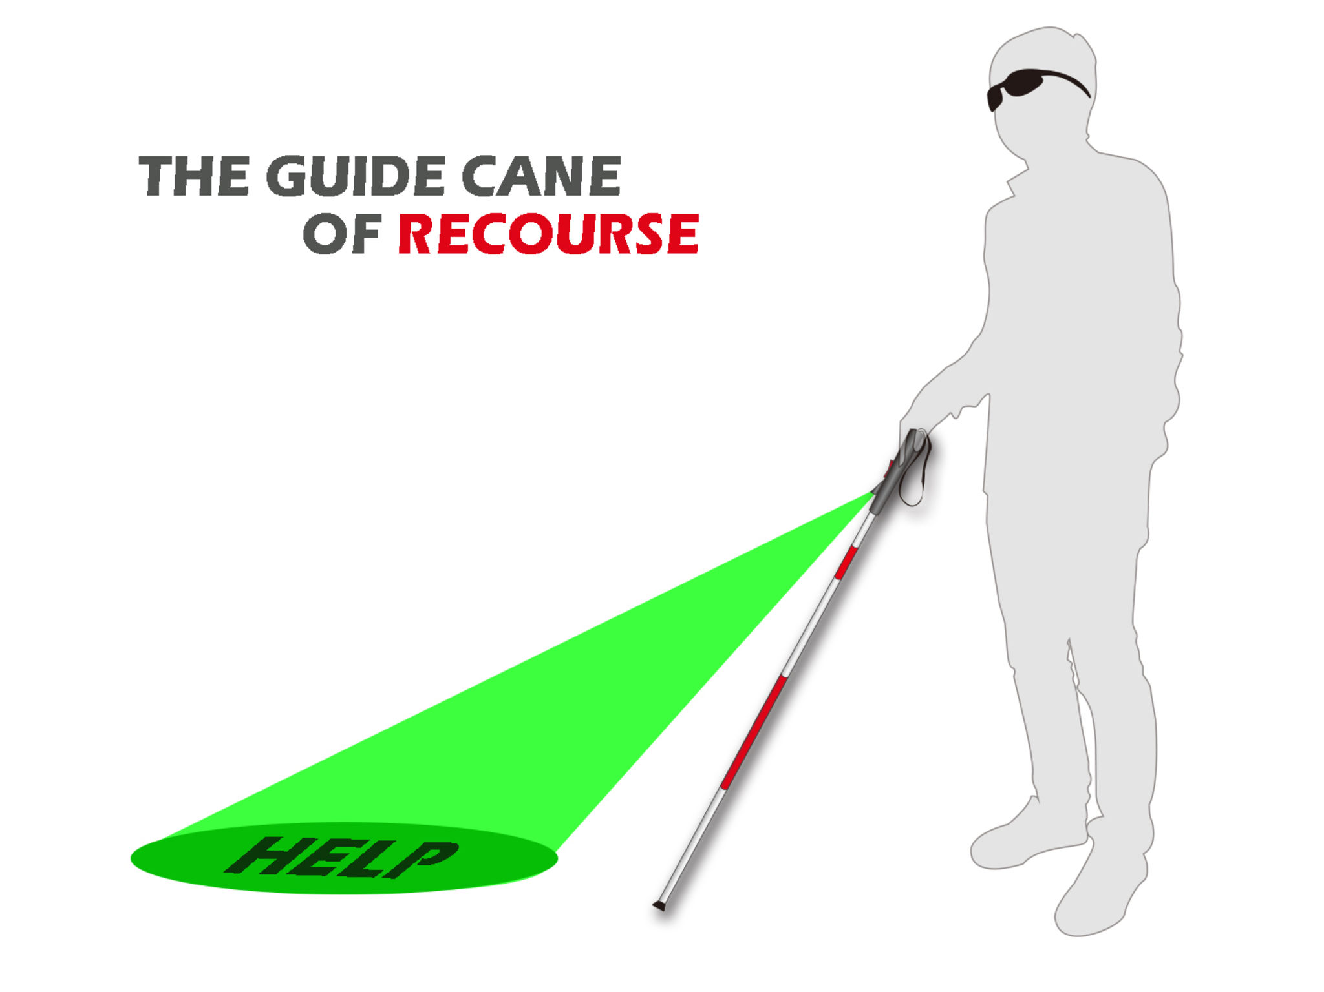
Support cane:

Designed primarily to offer physical stability to a visually impaired user, the cane also works as a means of identification. It has very limited potential as a mobility device.


Some blind individuals pet a dog of various breeds to guide them.
Pet dog:
But it can cost much them to get their daily expenses, food & caring.
By some sort of short guide, a visually impaired person can think of pet dog to introduce in his/her daily life.


Owning pets is a source of comfort and joy to people from all walks of life, and those with visual impairments are no exception.

Benefits to Owning Pets While Visually Impaired

Physical and Mental Benefits:

Pet ownership has been linked to decreased blood pressure and cholesterol levels. Additionally, pet owners report reduced levels of loneliness and stress.
For many people, living with a visual impairment can feel inherently lonely at times, and the unconditional comfort of a pet can be an importance solace.

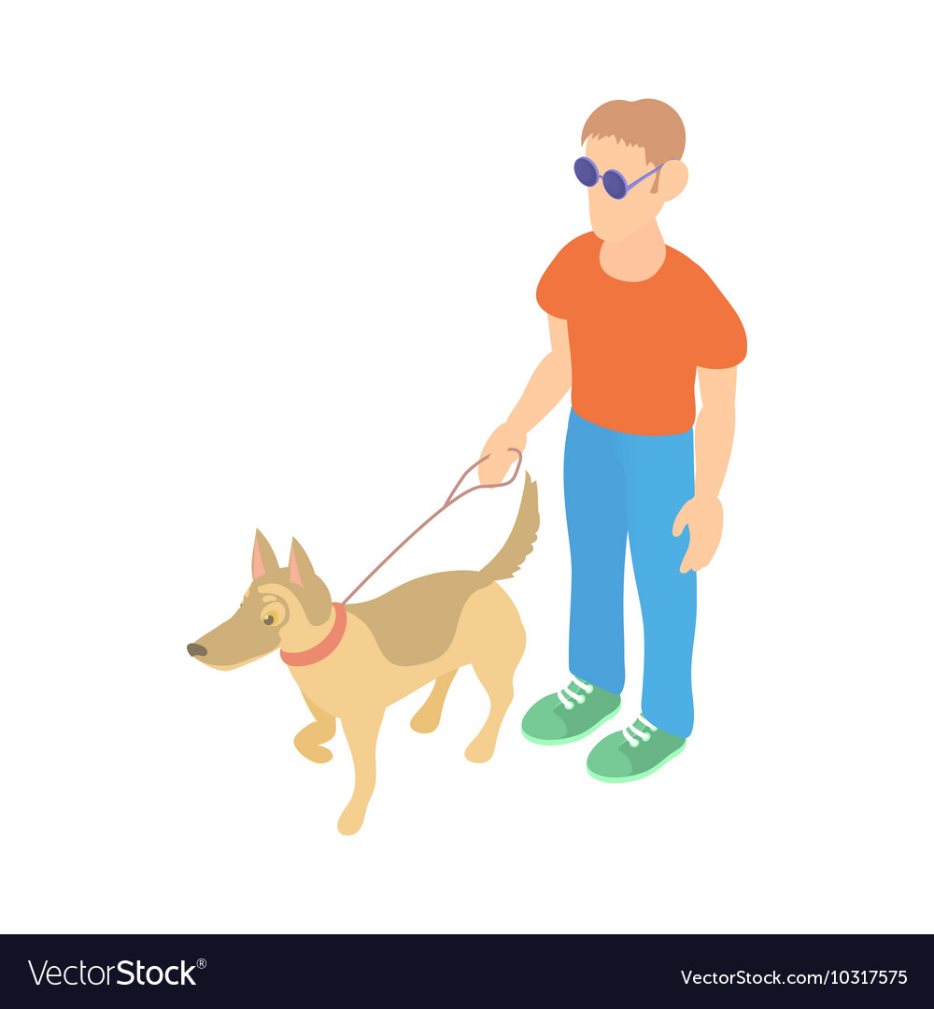
Socialization Benefits:
Pets, particularly dogs, provide a great opportunity for visually impaired owners to increase their socialization with others. Dogs make great companions for a walk to the park, enjoying coffee at a sidewalk café, or stopping by a neighborhood barbeque.

Other Benefits:
Guide dogs are specifically trained to lead visually impaired owners around obstacles. For many blind people, guide dogs are a critical key to independent living.
Questions to consider before getting a pet

- What is a blind individual’s capacity to care for a pet?

Pets require vastly different types of daily care. For example, many cats can happily survive so long as there is food, water, and a litterbox available to them, while many dogs require daily vigorous exercise and frequent bathroom breaks.
Finding a pet with care requirements that match the owner’s capacity is critical for all pet lovers, both those with disabilities and those without.

- Can individual spend time with a pet before making a final decision ownership?

Whether individual select a dog, a cat, a fish, or even a bird, it is important to make a decision that will positively impact their wellness and not add any additional stress to individual’s life.

- What are individuals needs and how can a pet best support these needs?

Guide dogs are well known companions for many blind people, but these highly trained pets aren’t the only animals that can be helpful to a blind owner.

With all these guidance, visually impaired person can pet their dog for its purpose.
But this way is not much convenient as the individual is dependent very much on living thing (pet dog) which can be trouble to them.
Chapter 3
SYSTEM OVERVIEW
3.1 Hardware tools
These are the hardware material used for final invention build:

- Raspberry-Pi 3B+ Model (System On Chip)
- Overview
The Raspberry Pi 3 Model B+ is the latest product in the Raspberry Pi 3 range, boasting a 64-bit quad core processor running at 1.4GHz, dual-band 2.4GHz and 5GHz wireless LAN, Bluetooth 4.2/BLE, faster Ethernet, and PoE capability via a separate PoE (Power On Ethernet) HAT The dual-band wireless LAN comes with modular compliance certification, allowing the board to be designed into end products with significantly reduced wireless LAN compliance testing, improving both cost and time to market. The Raspberry Pi 3 Model B+ maintains the same mechanical footprint as both the Raspberry Pi 2 Model B and the Raspberry Pi 3 Model B.

- Specifications of the model
Processor:
Broadcom BCM283780, Cortex-A53, 64-bit SoC @ 1.4GHz.

Memory:
1 GB LPDDR2 SDRAM (Random Access Memory)

Connectivity:
2.4GHz and 5GHz IEEE 802.11.b/g/n/ac
wireless LAN, Bluetooth 4.2,
BLE Gigabit Ethernet over USB 2.0 (maximum throughput 300Mbps)
4 × USB 2.0 ports

Access:
Extended 40-pin GPIO header

Video & Sound:
1 × full size HDMI
MIPI DSI display port
MIPI CSI camera port
4 pole stereo output and composite video port

Multimedia:
H.264, MPEG-4 decodes (1080p30); H.264 encode (1080p30); OpenGL ES 1.1, 2.0 graphics

SD card support:
Micro SD format for loading operating system and data storage

Input Power:
5V/2.5A DC via micro USB connector
5V DC via GPIO header
Power over Ethernet (PoE)–enabled (requires separate PoE HAT)

Environment:
Operating temperature, 0–50°C

Compliance:
For a full list of local and regional product approvals, please visit www.raspberrypi.org/products/raspberry-pi-3-model-b+
Production Lifetime:
The Raspberry Pi 3 Model B+ will remain in production until at least January 2023.

- Physical Specifications:
Warnings:
- This product should only be connected to an external power supply rated at 5V/2.5 A DC. Any external power supply used with the Raspberry Pi 3 Model B+ shall comply with relevant regulations and standards applicable in the country of intended use

- This product should be operated in a well-ventilated environment and, if used inside a case, the case should not be covered.

- Whilst in use, this product should be placed on a stable, flat, non-conductive surface and should not be contacted by conductive items.

- The connection of incompatible devices to the GPIO connection may affect compliance, result in damage to the unit, and invalidate the warranty.
- All peripherals used with this product should comply with relevant standards for the country of use and be marked accordingly to ensure that safety and performance requirements are met. These articles include but are not limited to keyboards, monitors, and mice when used in conjunction with the Raspberry Pi.

- The cables and connectors of all peripherals used with this product must have adequate insulation so that relevant safety requirements are met.
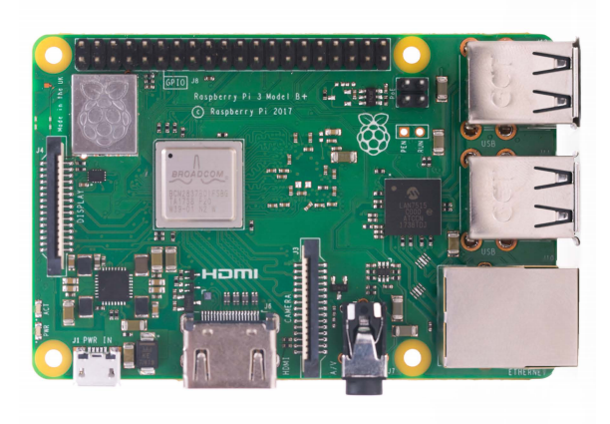

d) Mechanical Drawing of Raspberry-Pi Circuit:

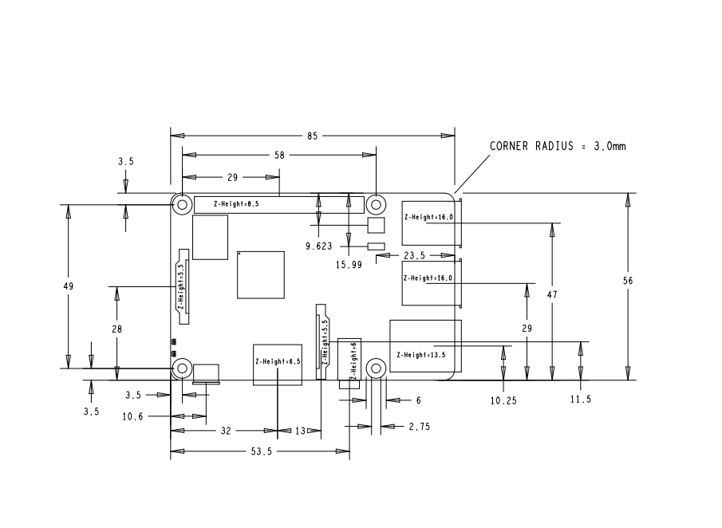

e) Safety Instructions While Using SoC:
1) To avoid malfunction of or damage to this product, please observe the following:
2) Do not expose to water or moisture, or place on a conductive surface whilst in operation
3) Do not expose to heat from any source; the Raspberry Pi 3 Model B+ is designed for reliable operation at normal ambient temperatures.
4) Do not expose the printed circuit board to high-intensity light sources (e.g. xenon flash or laser) whilst in operation
5) Take care whilst handling to avoid mechanical or electrical damage to the printed circuit board and connectors
6) Whilst it is powered, avoid handling the printed circuit board, or only handle it by the edges to minimize the risk of electrostatic discharge damage.
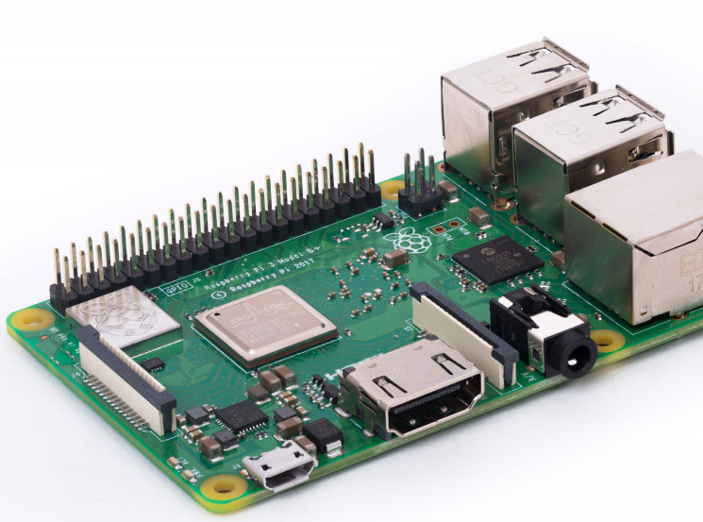
- Breadboard
A breadboard is a solderless device for temporary prototype with electronics and test circuit designs. Most electronic components in electronic circuits can be interconnected by inserting their leads or terminals into the holes and then making connections through wires where appropriate. The breadboard has strips of metal underneath the board and connect the holes on the top of the board. The metal strips are laid out as shown below. Note that the top and bottom rows of holes are connected horizontally and split in the middle while the remaining holes are connected vertically.

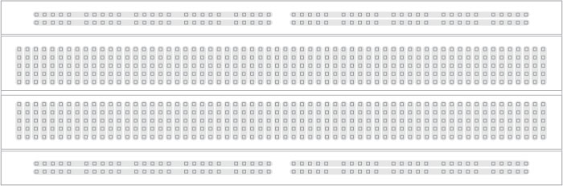

Note how all holes in the selected row are connected together, so the holes in the selected column. The set of connected holes can be called a node:

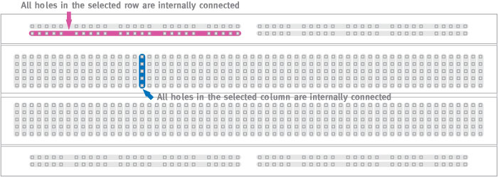

To interconnect the selected row (node A) and column (node B) a cable going from any hole in the row to any hole in the column is needed:

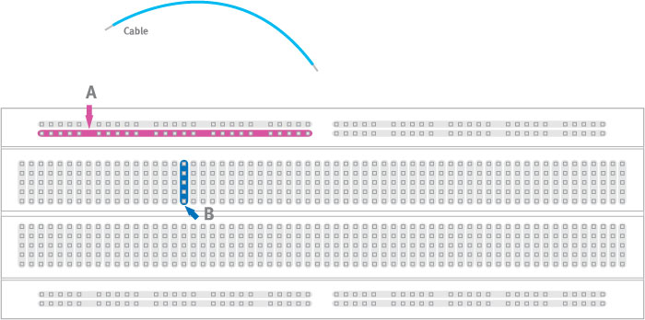
Now the selected column (node B) and row (node A) are interconnected:
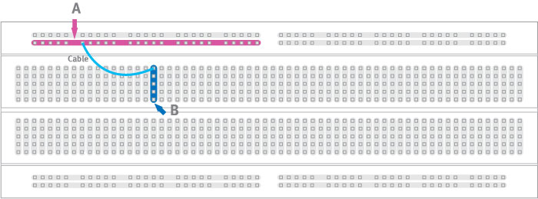

- Coin Vibrating Motor

- Coin vibration motors are designed to be easy to mount. They come with either spring PCB connectors or a high-strength long life self-adhesive backing sheet that is pre-attached to the underside of the chassis. The adhesive allows for a secure mounting of the vibration motor to a wide range of surfaces such as PCBs or flat internal surfaces of the enclosure and makes manufacturing installation fast and clean.
Three brands of adhesive are typically used on our coin vibrator motors depending on availability (they all have very similar specifications).

Precision Microdrive’s currently produces coin vibration motors, also known as shaftless or pancake vibrator motors, generally in Ø8mm - Ø12mm diameters for our Pico Vibe range. Pancake motors are compact and convenient to use. They integrate into many designs because they have no external moving parts, and can be affixed in place with a strong permanent self-adhesive mounting system.
Enclosures can easily be molded to accept the coin form of our shaftless vibration motors. Within the coin motor range.
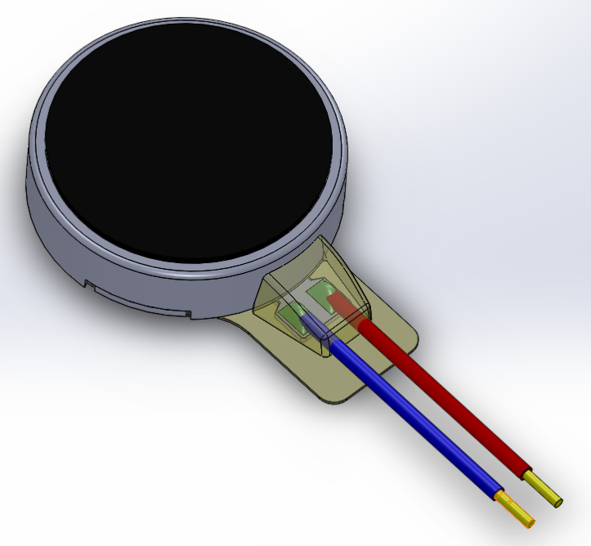

Applications

Due to their small size and enclosed vibration mechanism, coin vibrating motors are a popular choice for many different applications. They are great for haptics, particularly in handheld instruments where space can be at a premium:
- Mobile phones
- RFID scanners
- Industrial tools or equipment user interfaces
- Portable instruments
- Medical applications
- Mechanical Elaboration of Coin Vibration Motor:

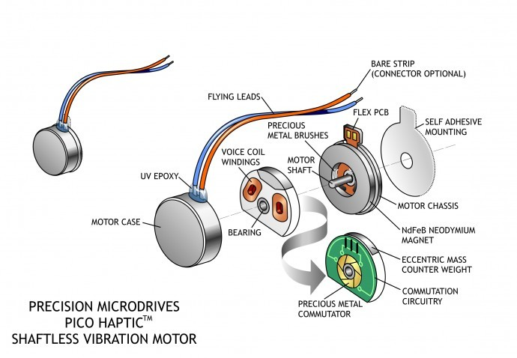

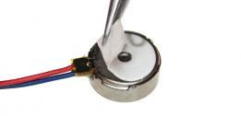
Self-Adhesive Coin Vibration Motor

- LED Indicators

  - A light-emitting diode (LED) is a semiconductor light source that emits light when current flows through it. Electrons in the semiconductor recombine with electron holes, releasing energy in the form of photons. The color of the light (corresponding to the energy of the photons) is determined by the energy required for electrons to cross the band gap of the semiconductor. White light is obtained by using multiple semiconductors or a layer of light-emitting phosphor on the semiconductor device.

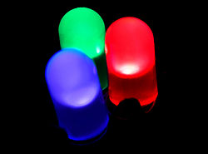
  - Parts of Conventional LED

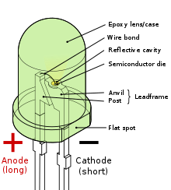
Chapter 4
4.1) System Hardware
- Ultrasonic Sensor

- An ultrasonic sensor is an electronic device that measures the distance of a target object by emitting ultrasonic sound waves, and converts the reflected sound into an electrical signal. Ultrasonic waves travel faster than the speed of audible sound (i.e. the sound that humans can hear). Ultrasonic sensors have two main components: the transmitter (which emits the sound using piezoelectric crystals) and the receiver (which encounters the sound after it has travelled to and from the target).
- In order to calculate the distance between the sensor and the object, the sensor measures the time it takes between the emission of the sound by the transmitter to its contact with the receiver. The formula for this calculation is D = ½ T x C (where D is the distance, T is the time, and C is the speed of sound ~ 343 meters/second). For example, if a scientist set up an ultrasonic sensor aimed at a box and it took 0.025 seconds for the sound to bounce back, the distance between the ultrasonic sensor and the box would be about 4.2875 meters.

Working Morphology Of Ultrasonic Sensor

- Ultrasonic sensors are used primarily as proximity sensors. They can be found in automobile self-parking technology and anti-collision safety systems. Ultrasonic sensors are also used in robotic obstacle detection systems, as well as manufacturing technology. In comparison to infrared (IR) sensors in proximity sensing applications, ultrasonic sensors are not as susceptible to interference of smoke, gas, and other airborne particles (though the physical components are still affected by variables such as heat).
- Ultrasonic sensors are also used as level sensors to detect, monitor, and regulate liquid levels in closed containers (such as vats in chemical factories). Most notably, ultrasonic technology has enabled the medical industry to produce images of internal organs, identify tumors, and ensure the health of babies in the womb.

How is ultrasonic sensor are used?
- Ultrasonic distance, level, and proximity sensors are commonly used with microcontroller platforms like Raspberry Pi, ARM, PIC, Arduino, Beagle Board, and more.
- Ultrasonic sensors transmit sound waves toward a target and will determine its distance by measuring the time it took for the reflected waves to return to the receiver.
- This sensor is an electronic device that will measure the distance of a target by transmitting ultrasonic sound waves, and then will convert the reflected sound into an electrical signal.
- sensors are often used as proximity sensors.
- Ultrasonic sensors are also used in obstacle avoidance systems, as well as in manufacturing.
- Short-range sensors offer the opportunity for closer range detection where you may need a sensor that ranges objects as close to 2cm. These are also built with very low power requirements in mind, as well as environments where noise rejection is necessary.
*** Note: It is possible that small grains or particles will deflect the ultrasonic pulses away from the sensor due to surface variation or angle.
In these environments, the target may absorb sound or deflect sound energy away from the sensor due to the angle of repose, surface variation, or both. ***
Which offers an application note on small particle (grain) detention below…

Diagram for working and impact due to small particle
(Grain Particle)

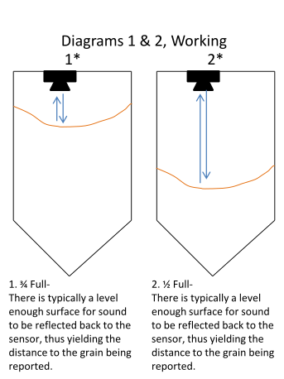
In some cases, the target object is so small that the reflected ultrasonic signal is insufficient for detection, and the distance cannot be measured correctly which will lead to the incorrect distance detection to the blind individual.

Ultrasonic Sensors are best used in the non-contact detection of:
- Presence
- Level
- Position
- Distance
Non-contact sensors are also referred to as proximity sensors.

Ultrasonic are Independent of:
- Light
- Smoke
- Dust
- Color
- Material (except for soft surfaces, i.e. wool, because the surface absorbs the ultrasonic sound wave and doesn’t reflect sound.)

Ultrasonic sensors are superior to infrared sensors because they aren’t affected by smoke or black materials, however, soft materials which don’t reflect the sonar (ultrasonic) waves very well may cause issues. It’s not a 100% perfect system, but it’s good and reliable.
- Jumper Cables
  - A jump wire/cables (also known as jumper, jumper wire, jumper cable, DuPont wire or cable) is an electrical wire, or group of them in a cable, with a connector or pin at each end (or sometimes without them – simply "tinned"), which is normally used to interconnect the components of a breadboard or other prototype or test circuit, internally or with other equipment or components, without soldering.
  - Individual jump wires are fitted by inserting their "end connectors" into the slots provided in a breadboard, the header connector of a circuit board, or a piece of test equipment.

What do the colors mean here?
- Though jumper wires come in a variety of colors, the colors don’t actually mean anything. This means that a red jumper wire is technically the same as a black one. But the colors can be used to your advantage in order to differentiate between types of connections, such as ground or power.

Types of jumper wires
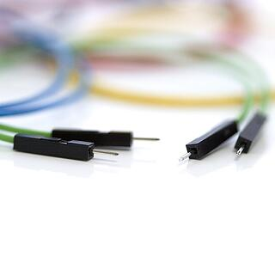

b) Jumper wires/cables typically come in three versions: male-to-male, male-to-female and female-to-female. The difference between each is in the end point of the wire. Male ends have a pin protruding and can plug into things, while female ends do not and are used to plug things into. Male-to-male jumper wires are the most common and what you likely will use most often. When connecting two ports on a breadboard, a male-to-male wire is needed
- Power Bank as Battery to The System
- Power banks are used for providing portable power to charge battery powered items like mobile phones and other similar items that have a USB interface:
- They can charge via USB, etc. or wirelessly.
- Power banks are commonplace and with our increasing use of battery powered equipment: everything from mobile phones to battery powered headphones, portable speakers, MP3 players can be charged via a power bank. They are effectively a portable charger. All they need is a USB charging interface.
- Power banks come in a variety of shapes and sizes and to suit many different people and their needs.
- In recent years, the use of power banks has risen significantly as they provide a very convenient and easy method of charging smartphones and other devices when away from mains power. Wireless charging power banks have also been introduced for those devices that can be charged wirelessly.

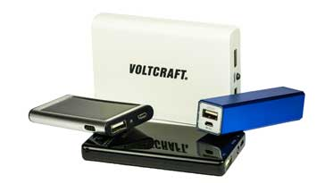

Power bank definition

- Power banks, sometimes speed as power banks, can be defined as portable batteries that use circuitry to control any power in and power out. They can have charged up using a USB charger when power is available, and then used to charge battery powered items like mobile phones and a host of other devices that would normally use a USB charger.
- The name power bank can be likened to a financial bank where funds can be deposited, stored, and withdrawn when needed. These items are also often referred to as portable chargers, as they can charge items like mobile phones without the need to be connected to the mains during charging, although they will need to be charged, and this normally requires a mains charger.
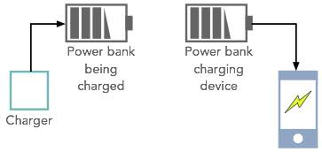
- Here in this case instead of mobile device, we are using raspberry-pi (SoC) to get portable energy from typical standard power bank.

Power bank types
There are a few different types of power bank portable charger that can be bought. Obviously the size is one of the main criteria, but there are some other categories that can be considered.
The main types of USB power banks include the following:
- Universal or standard power bank: These are the normal power bank portable chargers which are available in the stores and online. They are charged from the normal USB sources like USB chargers.
These power banks are normally charged from a standard USB charger and there is some indication on the power bank as to its state of charge. This may be a row of small LED lamps or a simple alphanumeric display that indicates the charge level as a percentage of full charge. Typically, a micro USB connector is used as the power in connection.
Once fully charged the power bank can be used to charge other devices. There may be one of more Type A USB sockets (dependent upon the particular power bank) that can deliver charge to the devices needing charging.

. Wireless power bank: With many gadgets like phones, ear-pods and the like now having the capability to be charged wirelessly, this concept has been adopted by the power bank industry.
It is possible to obtain power banks that are themselves charged from a standard USB source, but they are able to charge phones and other wireless charging compatible electronic devices wirelessly.

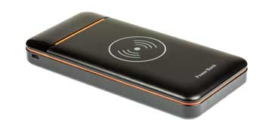
These power banks use the Qi standard that has been adopted by virtually all electronic devices that can be charged wirelessly. The electronic device to be changed is placed on the power bank - orientation is often important, so check with the instructions, a button typically has to be pressed to turn on the wireless charging capability, and then it all proceeds until the device is charged.
It is best to turn off the wireless charging power bank once the charging is complete and then the wireless charging circuitry is disabled and the power bank will not be discharged unnecessarily.
Note:
Here in this project, we are just using typical standard power bank.

Power bank technology
All power banks use rechargeable batteries based around lithium technology. Lithium-Ion and Lithium-Polymer batteries are most commonly used for power banks but don’t be surprised if other types start to hit the market before long. Battery technology is key to many new developments: everything from mobile phones to electric vehicles, and as a result it is quite likely there will be some spin-offs into power banks.
The two technologies that are currently used have slightly different properties:

- Lithium-ion: Lithium-Ion batteries have a higher energy density, i.e. they can store more electrical charge in a given size or volume, and are cheaper to manufacture, but they can have issues with ageing.
- Lithium-polymer: Lithium-polymer power banks do not suffer from ageing to the same extent so are a better choice. However, they are costlier to manufacture and as a result they may not suit all budgets. Sometimes it may be that it is best to spend less, especially if they are likely to be accidentally lost.

Both forms of power bank work well, but it is a balance between cost and performance.
Power bank portable chargers are particularly useful as they enable battery powered items to be charged on the go. As it is not always possible to reach a mains power point every time a mobile phone or other battery powered item needs charging, these power banks are have now become an established product and they are very useful, especially when travelling & which is useful in our case.

Power bank lifetime
There are two main forms of lifetime that are associated with power banks.
- Charge discharge cycles: Any rechargeable battery will gradually wear out. Normally the lifetime of a battery is quoted in terms of the number of charge discharge cycles it can undergo before its performance falls by a given degree. Some cheaper power banks may only have a life of 500 or so charge discharge cycles, but better ones will have lifetimes of many more charge discharge cycles.
- Self-discharge time: All battery cells, whether rechargeable or primary have a certain level of self-discharge. For rechargeable batteries these days with their own control circuitry, a small amount of power is required to keep these circuits alive. As a result there is only a finite time that a battery will remain charged.
A good power bank can hold charge for up to 6 months with only a small loss of charge, but lower quality ones may only retain a useful charge for about a month. These figures are for room temperature, but storing them outside these temperatures considerably reduces their performance.

- Handy or Wearable Material

  - Gloves:
A glove is a garment covering the hand. Gloves usually have separate sheaths or openings for each finger and the thumb.
If there is an opening but no (or a short) covering sheath for each finger they are called fingerless gloves. Fingerless gloves having one small opening rather than individual openings for each finger are sometimes called gauntlets, though gauntlets are not necessarily fingerless.
A hybrid of glove and mitten contains open-ended sheaths for the four fingers (as in a fingerless glove, but not the thumb) and an additional compartment encapsulating the four fingers. This compartment can be lifted off the fingers and folded back to allow the individual fingers ease of movement and access while the hand remains covered.
Here, we can use any handy or wearable material according to the placing of device by the choice of blind individual. (such as belt and fitness band).

- Headphones for text-to-speech conversion
- Headphones are small speakers that can be worn in or around your ears. Traditional headphones have two ear cups attached by a band that is placed over your head. Smaller headphones, often called earbuds or earphones, are placed inside the outer part of your ear canal.
- Like speakers, headphones contain transducers that convert an audio signal into sound waves. Headphones that connect to an analog audio port (such as a 3.5 mm audio jack) process analog audio. Headphones that connect to a digital port, such as a USB or Lightning port process digital audio. Digital headphones must also include a digital-to-analog converter, or DAC, in order to produce the analog output.

- While headphones function the same way as standalone speakers, their output is significantly different. Speakers must generate enough amplitude for the sound to be audible from far away. Headphones only need to send the sound waves a few millimeters to your ear drums. Therefore, headphone components are much smaller and often more precise than speaker components. Even though the output is much lower than standalone speakers, the close proximity of headphones to your ears can make the volume sound very loud. Most headphones even support the full 20 hertz to 20,000 Hz frequency range. However, the bass is less noticeable since they don't move as much air.
- Here, in this project we are using normal typical standard wired earphones to get Text-to-Speech conversion from “Espeak” library from raspberry-pi.

9) Buzzer
A buzzer or beeper is an audio signaling device, [ which may be mechanical, electromechanical, or piezoelectric (piezo for short). Typical uses of buzzers and beepers include alarm devices, timers, and confirmation of user input such as a mouse click or keystroke.

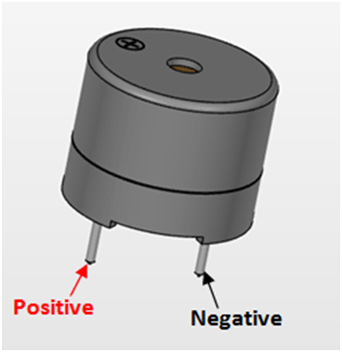

A piezoelectric element may be driven by an oscillating electronic circuit or other audio signal source, driven with a piezoelectric audio amplifier. Sounds commonly used to indicate that a button has been pressed are a click, a ring or a beep.

Piezo buzzers are used in similar applications as magnetic buzzers. Piezo buzzers are constructed by placing electrical contacts on the two faces of a disk of piezoelectric material and then supporting the disk at the edges in an enclosure. When a voltage is applied across the two electrodes, the piezoelectric material mechanically deforms due to the applied voltage. This movement of the piezo disk within the buzzer creates sound in a similar manner as the movement of the ferromagnetic disk in a magnetic buzzer or the speaker cone mentioned above.

Chapter 5
5.1) System software
a) Thonny python editor

Thonny is an integrated development environment for Python that is designed for beginners. It supports different ways of stepping through the code, step-by-step expression evaluation, detailed visualization of the call stack and a mode for explaining the concepts of references and heap.

b) Features
- Line numbers
- Statement stepping without breakpoints
- Live variables during debugging
- Stepping through evaluation of the expressions (expressions get replaced by their values)
- Separate windows for executing function calls (for explaining local variables and call stack)
- Variables and memory can be explained either by using simplified model (name → value) or by using more realistic model (name → address/id → value)
- Simple pip GUI
- Support for Python and Micro Python
- Support for running and managing files on a remote machine via SSH
- Possibility to log user actions for replaying or analyzing the programming process
c) Availability
The program works on Windows, macros and Linux. It is available as binary bundle including recent Python interpreted or pip-installable package. It can be installed via operating-system package manager on Delian, Raspberry Pi, Ubuntu and Fedora.
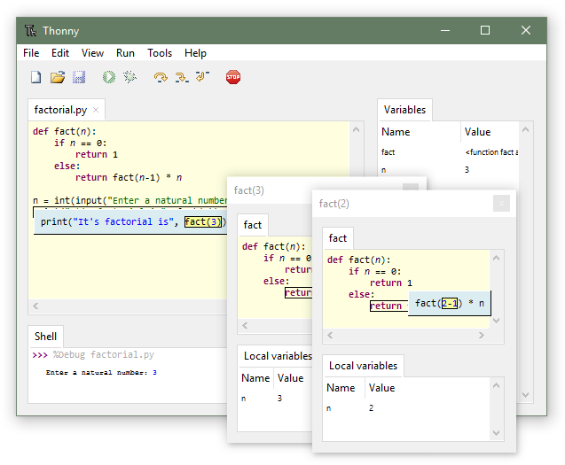
d) Reception
Thonny has received favorable reviews from Python and computer science education communities. It has been recommended tool in several programming MOOCs. Since June 2017 it has been included by default in the Raspberry Pi's official operating system distribution Raspberry Pi operating system.

5.2) Raspberry-Pi Operating System
(NOOBS)
New Out of Box Software (NOOBS) is an easy operating system installation manager for the Raspberry Pi.
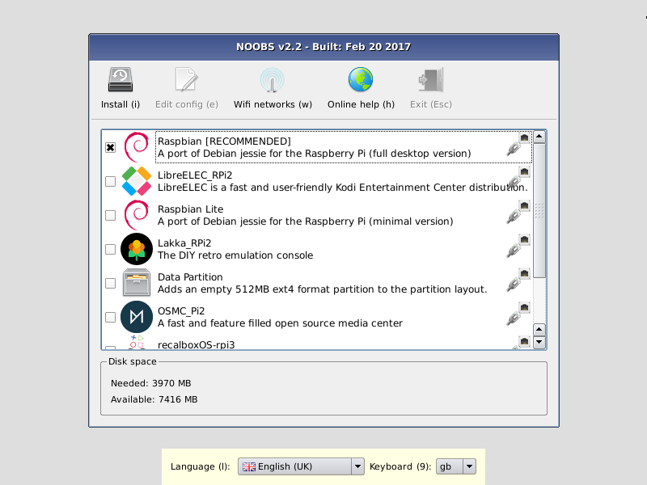

How to get NOOBS

Buy a pre-installed SD card
SD cards with NOOBS preinstalled are available from many of our distributors and independent retailers, including Pimoroni, Adafruit, and Pi Hut.

Download
Alternatively, NOOBS is available for download on the Raspberry Pi website: raspberrypi.org/downloads

How to install NOOBS on an SD card
Once you've downloaded the NOOBS zip file, you'll need to copy the contents to a formatted SD card on your computer.
To set up a blank SD card with NOOBS:
- Format an SD card as FAT. See the instructions given below.
  - Your SD card will need to be at least 16GB for Full Raspberry Pi OS, or at least 8GB for all other installs.
- Download and extract the files from the NOOBS zip file.
- Copy the extracted files onto the SD card that you just formatted, so that these files are at the root directory of the SD card. Please note that in some cases it may extract the files into a folder; if this is the case, then please copy across the files from inside the folder rather than the folder itself.
- On first boot, the "RECOVERY" FAT partition will be automatically resized to a minimum, and a list of OSes that are available to install will be displayed.

How to format an SD card as FAT
Note: If you're formatting an SD (or micro SD) card that has a capacity over 32GB (i.e. 64GB and above), then see the separate SDXC formatting instructions.

Windows
If you are a Windows user, we recommend formatting your SD card using the SD Association's Formatting Tool, which can be downloaded from sdcard.org. Instructions for using the tool are available on the same site.

Mac OS
The SD Association's Formatting Tool is also available for Mac users, although the default OS X Disk Utility is also capable of formatting the entire disk. To do this, select the SD card volume and choose Erase with MS-DOS format.

Linux
For Linux users we recommend gparted (or the command line version parted). Norman Dunbar has written up instructions for Linux users.

What's included in NOOBS
The following operating systems are currently included in NOOBS:
- Raspberry Pi OS
- LibreELEC
- OSMC
- Recalbox
- Lakka
- RISC OS
- Screenplay OSE
- Windows 10 IoT Core
- TLXOS
As of NOOBS v1.3.10 (September 2014), only Raspberry Pi OS is installed by default in NOOBS. The others can be installed with a network connection.

NOOBS and NOOBS Lite
NOOBS is available in two forms: offline and network install, or network install only.
The full version has Raspberry Pi OS included, so it can be installed from the SD card while offline, whereas using NOOBS Lite or installing any other operating system requires an internet connection.
Note that the operating system image on the full version can be outdated if a new version of the OS is released, but if connected to the internet you will be shown the option of downloading the latest version if there is a newer one available.

NOOBS development

Latest NOOBS release
The latest NOOBS release is v3.6.0, released on 22nd March 2021.
(From NOOBS v1.4.0 onwards, NOOBS Lite only shares the first two digits of the version number, i.e. v1.4)

NOOBS documentation
More comprehensive documentation, including more advanced configuration of NOOBS, is available on GitHub.

NOOBS source code
See the NOOBS source code on GitHub.

5.3) Fritzing software
a) Fritzing is an open-source initiative to develop amateur or hobby CAD software for the design of electronics hardware, to support designers and artists ready to move from experimenting with a prototype to building a more permanent circuit. It was developed at the University of Applied Sciences Potsdam.

  - The software is created in the spirit of the Processing programming language and the Arduino microcontroller and allows a designer, artist, researcher, or hobbyist to document their Arduino-based prototype and create a PCB layout for manufacturing. The associated website helps users share and discuss drafts and experiences as well as to reduce manufacturing costs.
  - Fritzing can be seen as an electronic design automation (EDA) tool for non-engineers: the input metaphor is inspired by the environment of designers (the breadboard-based prototype), while the output is focused on accessible means of production. As of December 2, 2014 Fritzing has made a code view option, where one can modify code and upload it directly to an Arduino device.
  - The Fritzing source code is written in C++ using the Qt-framework. The source code can be downloaded and edited via the GitHub repositories. The source is split in two main repositories: Fritzing-App and Fritzing-Parts.
  - Fritzing is a great open source tool for anyone to teach, share, and prototype their electronic projects! It allows you to design a schematic, and thus a part, which can then be added to very professional-looking wiring diagrams. You can even design your own PCBs and have them fabricated from the files you design.



5.4) Circuit diagram using fritzing software

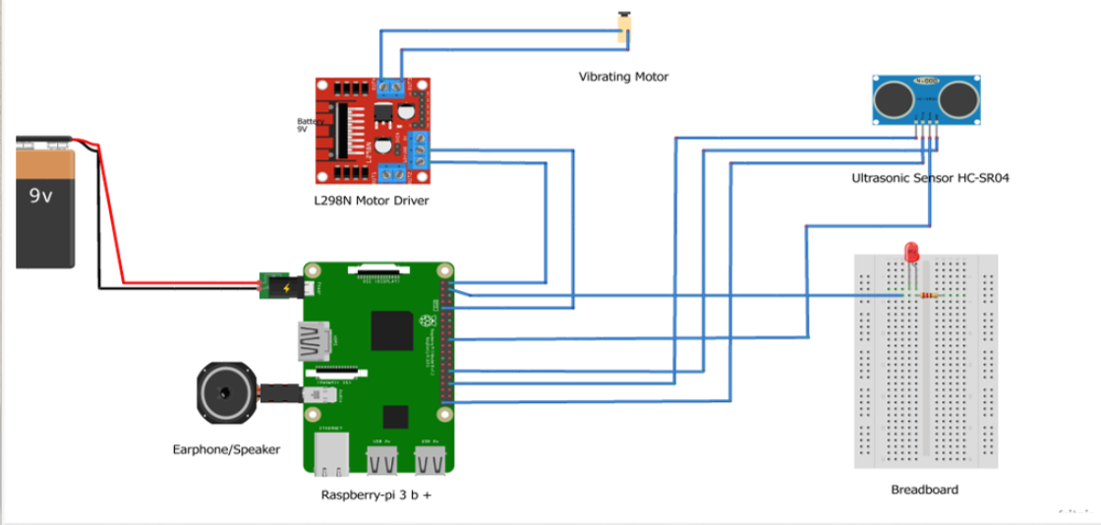

5.5) Block diagram of purposed system

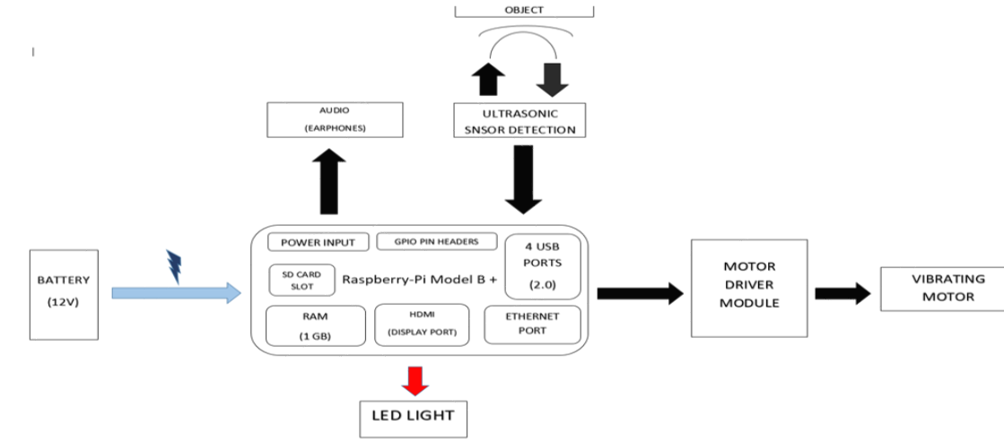

5.6) Entity-relationship diagram for purposed system

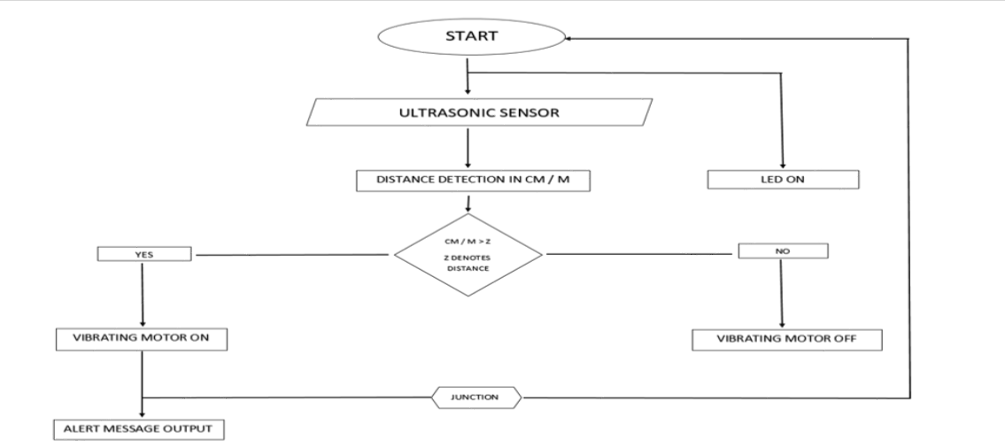

Chapter 6
6.1) Results
a) Code Snippet Created For Purposed System
#!/usr/bin/python
# Import required Python libraries
import RPi.GPIO as GPIO
import time
import espeak
# Using BCM GPIO numbering
GPIO.setmode(GPIO.BCM)
GPIO.setwarnings(False)
# GPIO pins selection
GPIO_BUZZER = 13
GPIO_TRIGGER = 18
GPIO_ECHO = 24
GPIO_INDICATOR = 2
# Set buzzer to ouput mode
GPIO.setup(GPIO_BUZZER, GPIO.OUT)
# Set TRIGGER to OUTPUT mode
GPIO.setup(GPIO_TRIGGER, GPIO.OUT)
# Set ECHO to INPUT mode
GPIO.setup(GPIO_ECHO, GPIO.IN)
GPIO.setup(GPIO_INDICATOR, GPIO.OUT)
# Measures the distance between a sensor and an obstacle and returns the measured value
def distance():
# Send 10 microsecond pulse to TRIGGER
GPIO.output(GPIO_TRIGGER, True) # set TRIGGER to HIGH
time.sleep(0.00001) # wait 10 microseconds
GPIO.output(GPIO_TRIGGER, False) # set TRIGGER back to LOW
# Create variable start and assign it current time
start = time.time()
# Create variable stop and assign it current time
stop = time.time()s
# Refresh start value until the ECHO goes HIGH = until the wave is send
while GPIO.input(GPIO_ECHO) == 0:
start = time.time()
# Assign the actual time to stop variable until the ECHO goes back from HIGH to LOW = the wave came back
while GPIO.input(GPIO_ECHO) == 1:
stop = time.time()
# Calculate the time it took the wave to travel there and back
measuredTime = stop - start
# Calculate the travel distance by multiplying the measured time by speed of sound
distanceBothWays = measuredTime * 33112 # cm/s in 20 degrees Celsius
# Divide the distance by 2 to get the actual distance from sensor to obstacle
distance = distanceBothWays / 2
# Print the distance to see if everything works correctly
print("Distance : {0:5.1f}cm".format(distance))
# Return the actual measured distance
return distance
# Calculates the frequency of beeping depending on the measured distance
def beep_freq():
# Measure the distance
dist = distance()
# If the distance is bigger than 50cm, we will not beep at all
if dist > 200:
return -1
# If the distance is between 50 and 30 cm, we will beep once a second
elif dist <= 200 and dist >=180:
return 1
# If the distance is between 30 and 20 cm, we will beep every twice a second
elif dist < 180 and dist >= 160:
return 0.5
# If the distance is between 20 and 10 cm, we will beep four times a second
elif dist < 160 and dist >= 130:
return 0.2
elif dist < 130 and dist >= 100:
return 0.3
elif dist < 100 and dist >= 80:
return 0.4
elif dist < 80 and dist >= 50:
return 0.6
elif dist < 50 and dist >= 40:
return 0.7
# If the distance is smaller than 10 cm, we will beep constantly
else:
return 0
# Main function
def main():
try:
# Repeat till the program is ended by the user
while True:
# Get the beeping frequency
freq = beep_freq()
# No beeping
if freq == -1:
GPIO.output(GPIO_BUZZER, False)
GPIO.output(GPIO_INDICATOR, True)
time.sleep(1)
GPIO.output(GPIO_INDICATOR, False)
time.sleep(3)
elif freq == 1:
GPIO.output(GPIO_INDICATOR, True)
time.sleep(0.1)
GPIO.output(GPIO_INDICATOR, False)
time.sleep(2)
GPIO.output(GPIO_BUZZER, True)
time.sleep(0.2)
GPIO.output(GPIO_BUZZER, False)
time.sleep(0.2)
elif freq == 0.2:
GPIO.output(GPIO_BUZZER, True)
time.sleep(0.1)
GPIO.output(GPIO_BUZZER, False)
time.sleep(0.1)
GPIO.output(GPIO_INDICATOR, True)
time.sleep(4)
GPIO.output(GPIO_INDICATOR, False)
time.sleep(0.1)
print(“Alert!!!,there is obstacle near”)
elif freq == 0.3:
GPIO.output(GPIO_BUZZER, True)
time.sleep(1)
GPIO.output(GPIO_BUZZER, False)
time.sleep(4)
GPIO.output(GPIO_INDICATOR, True)
time.sleep(1)
GPIO.output(GPIO_INDICATOR, False)
time.sleep(0.5)
elif freq == 0.4:
GPIO.output(GPIO_BUZZER, True)
time.sleep(1)
GPIO.output(GPIO_BUZZER, False)
time.sleep(2)
GPIO.output(GPIO_INDICATOR, True)
time.sleep(2)
GPIO.output(GPIO_INDICATOR, False)
time.sleep(2)
elif freq == 0.5:
GPIO.output(GPIO_INDICATOR, True)
time.sleep(3)
GPIO.output(GPIO_INDICATOR, False)
time.sleep(3)
GPIO.output(GPIO_BUZZER, True)
time.sleep(3)
GPIO.output(GPIO_BUZZER, False)
time.sleep(3)
elif freq == 0.6:
GPIO.output(GPIO_BUZZER, True)
time.sleep(1)
GPIO.output(GPIO_BUZZER, False)
time.sleep(2)
GPIO.output(GPIO_INDICATOR, True)
time.sleep(1)
GPIO.output(GPIO_INDICATOR, False)
time.sleep(0.5)
elif freq == 0.7:
GPIO.output(GPIO_BUZZER, True)
time.sleep(1)
GPIO.output(GPIO_BUZZER, False)
time.sleep(0.1)
GPIO.output(GPIO_INDICATOR, True)
time.sleep(1)
GPIO.output(GPIO_INDICATOR, False)
time.sleep(0.1)
# Constant beeping
elif freq == 0:
GPIO.output(GPIO_BUZZER, True)
time.sleep(0.25)
GPIO.output(GPIO_INDICATOR, True)
time.sleep(0.25)
GPIO.output(GPIO_INDICATOR, False)
time.sleep(0.25)
# Beeping on certain specified frequency
else:
GPIO.output(GPIO_BUZZER, True)
time.sleep(0.2) # Beep is 0.2 seconds long
GPIO.output(GPIO_BUZZER, False)
time.sleep(freq) # Pause between beeps = beeping frequency
# If the program is ended, stop beeping and send off signals to the GPIO
except KeyboardInterrupt:
GPIO.output(GPIO_BUZZER, False)
GPIO.cleanup()
# main execution
if __name__ == "__main__":
main()

6.2) Images of Working Module & Circuit

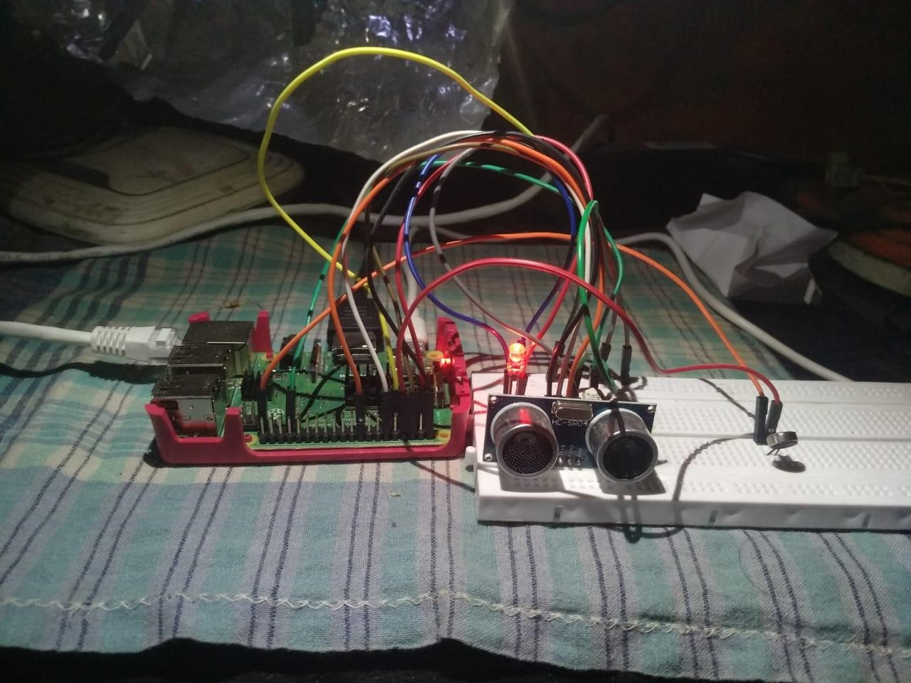

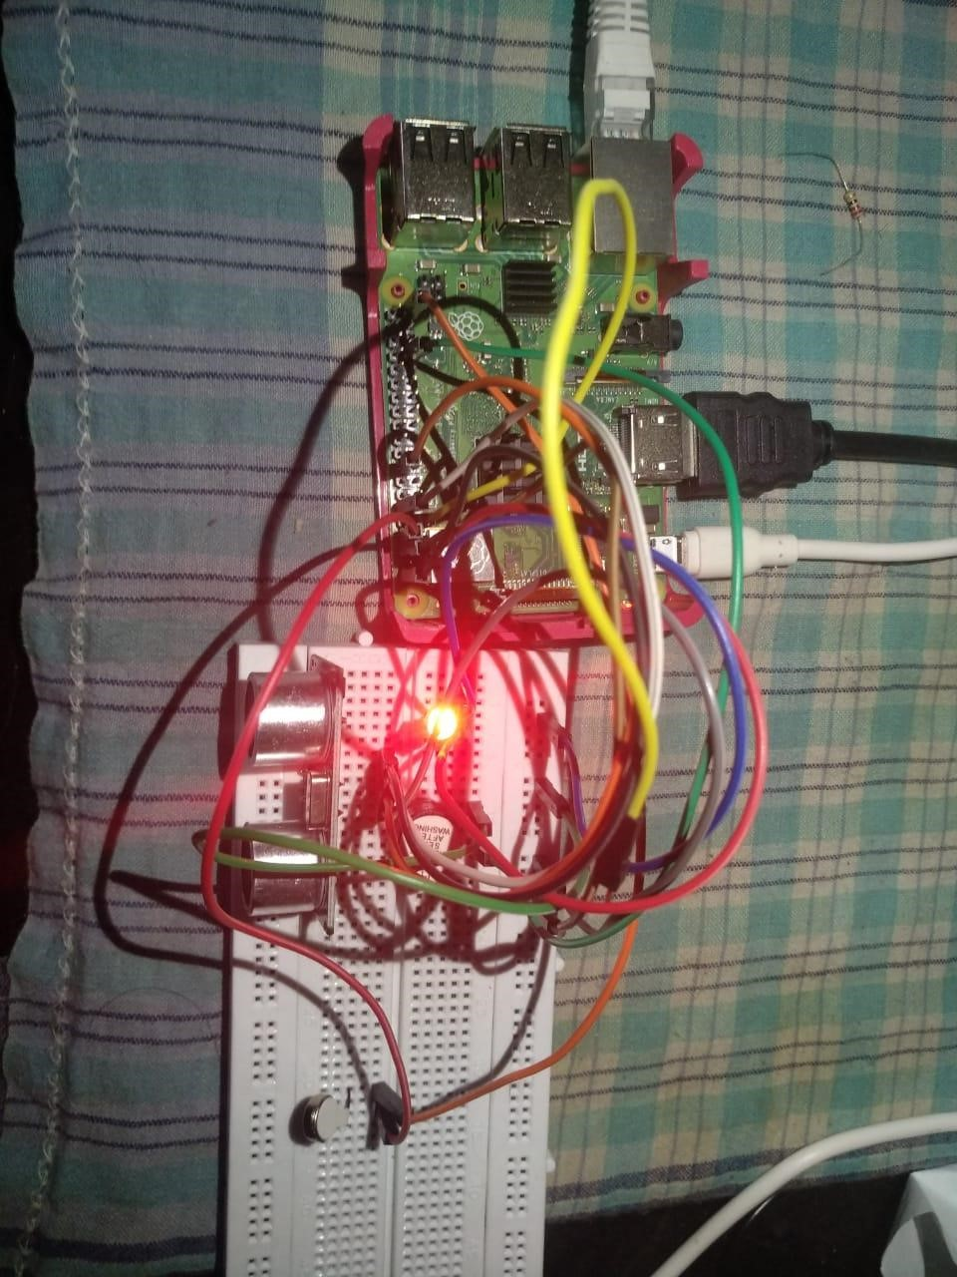

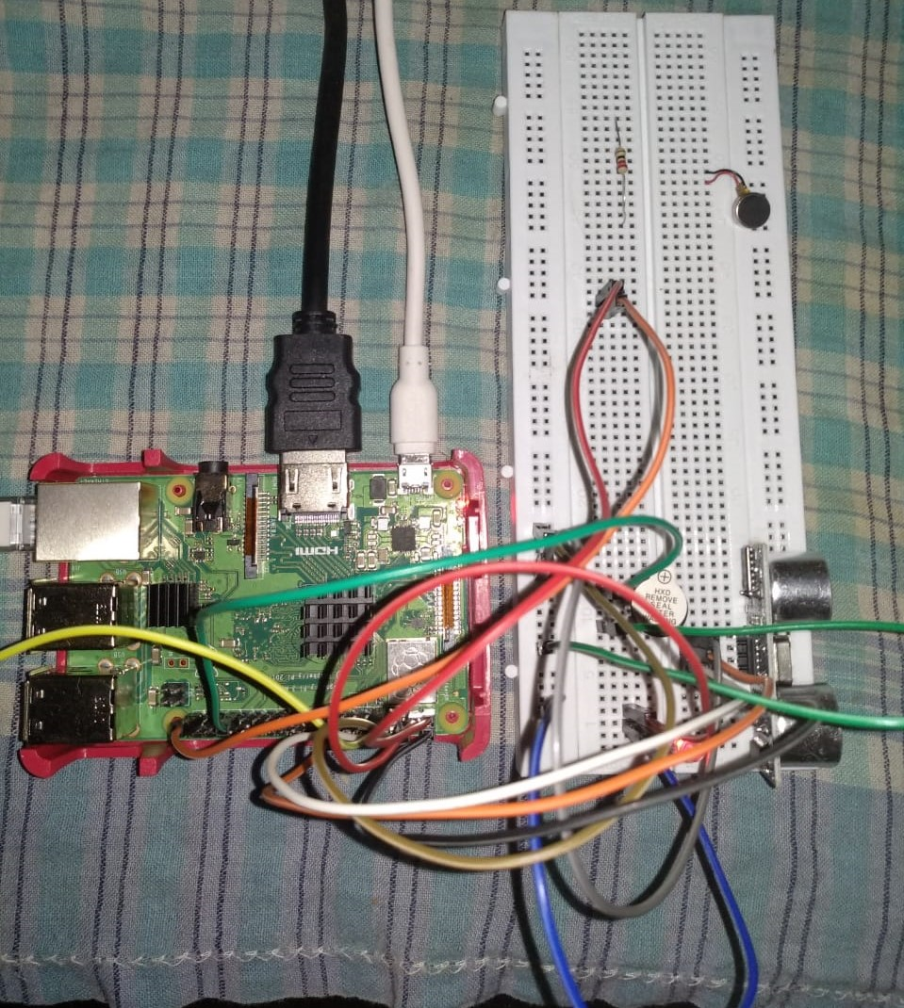

6.3) Snapshots of Raspberry-Pi booting system

- Selection of Operating system
(NOOB)

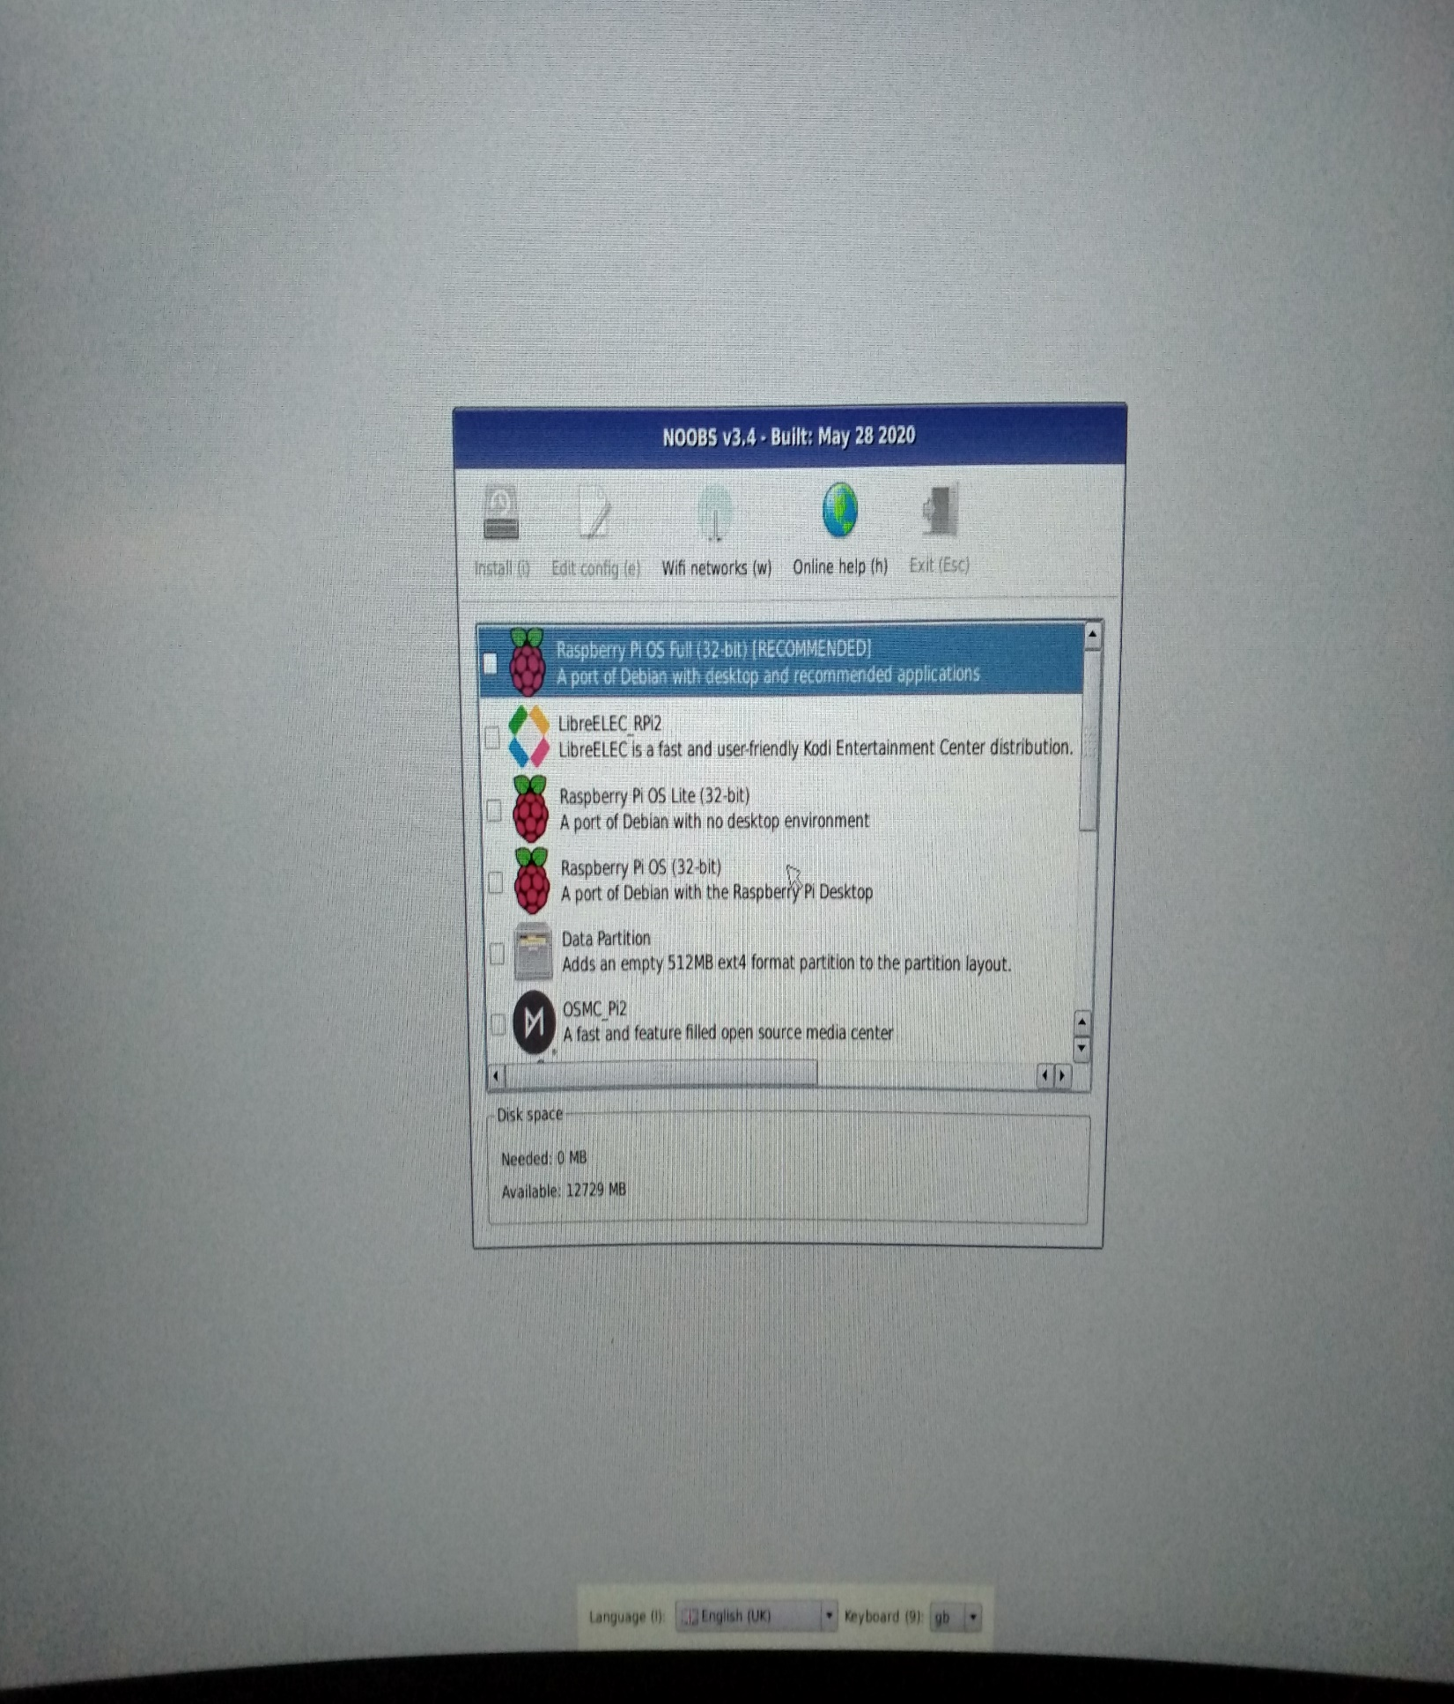

- Welcome screen of Raspberry-Pi Desktop

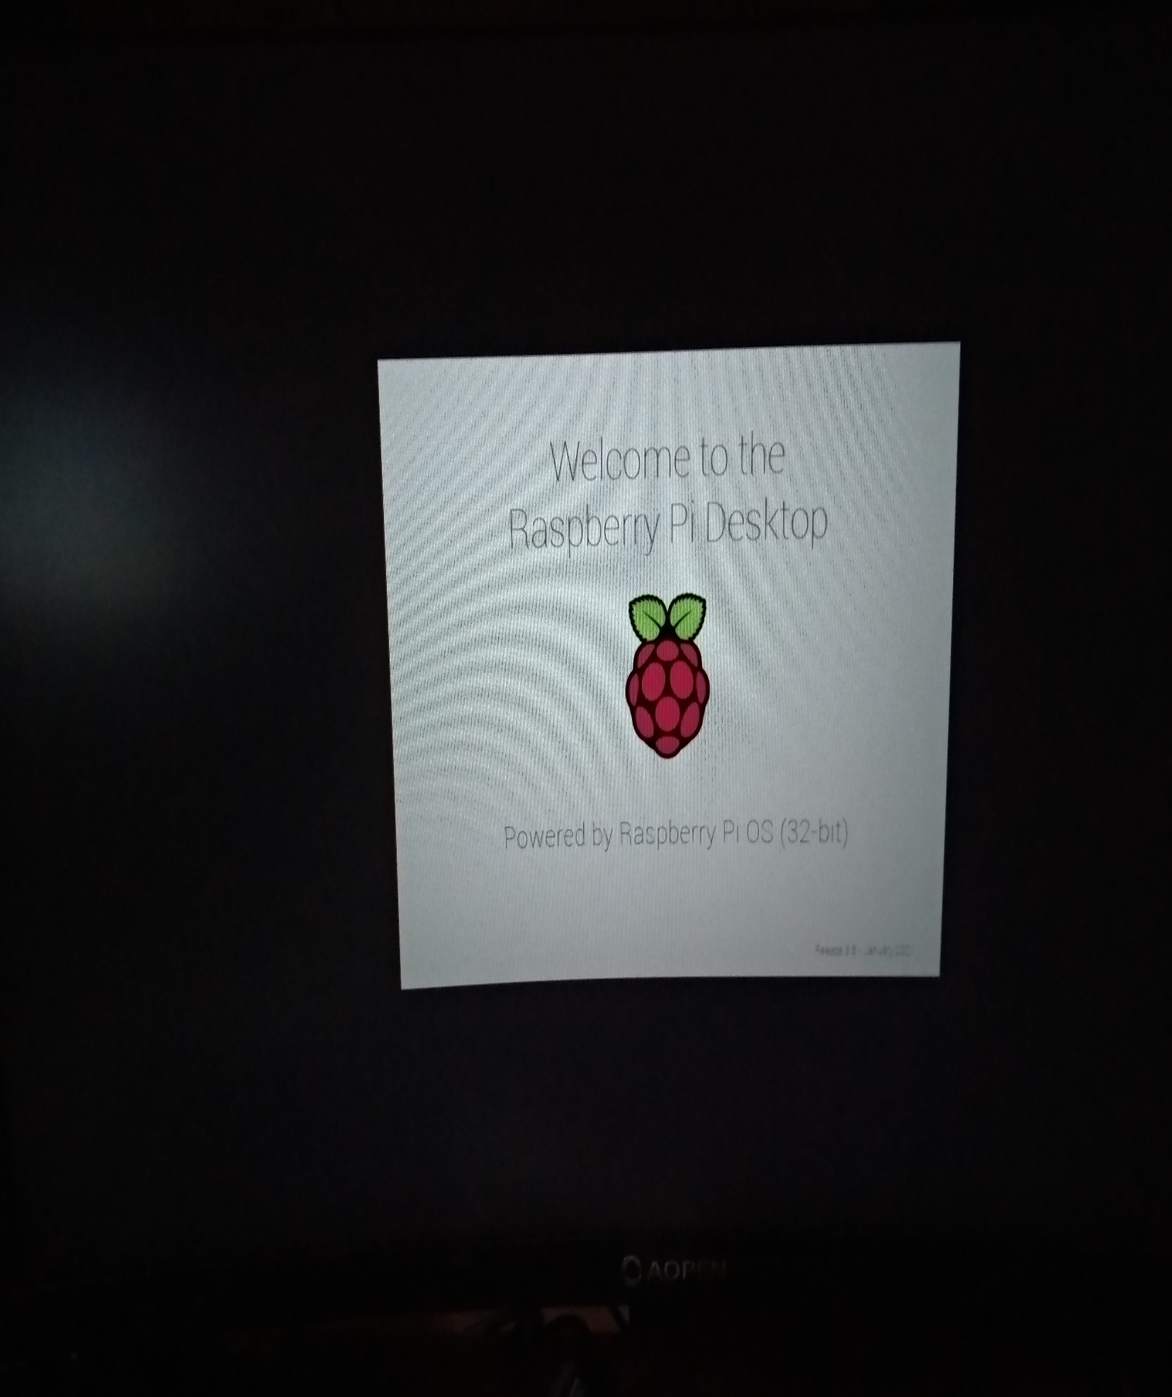

- Successfully installed operating system

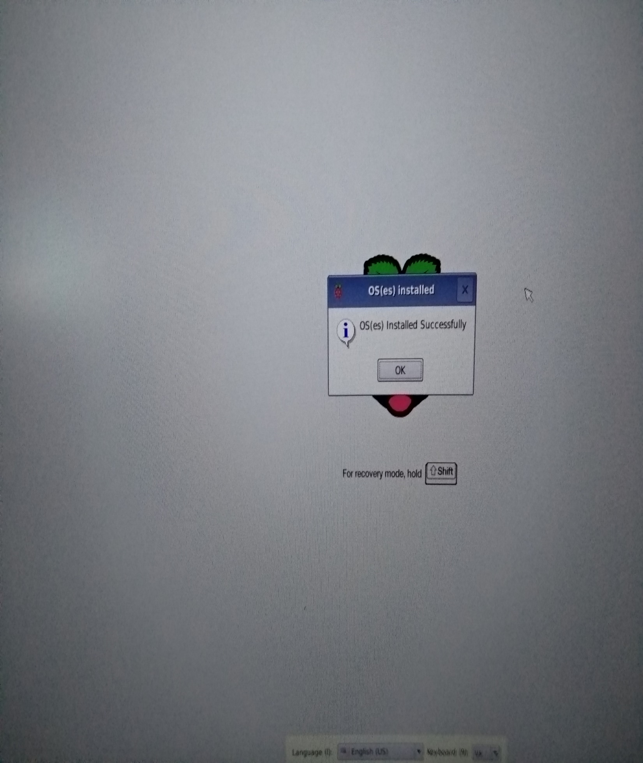

- Home screen of Raspberry-Pi

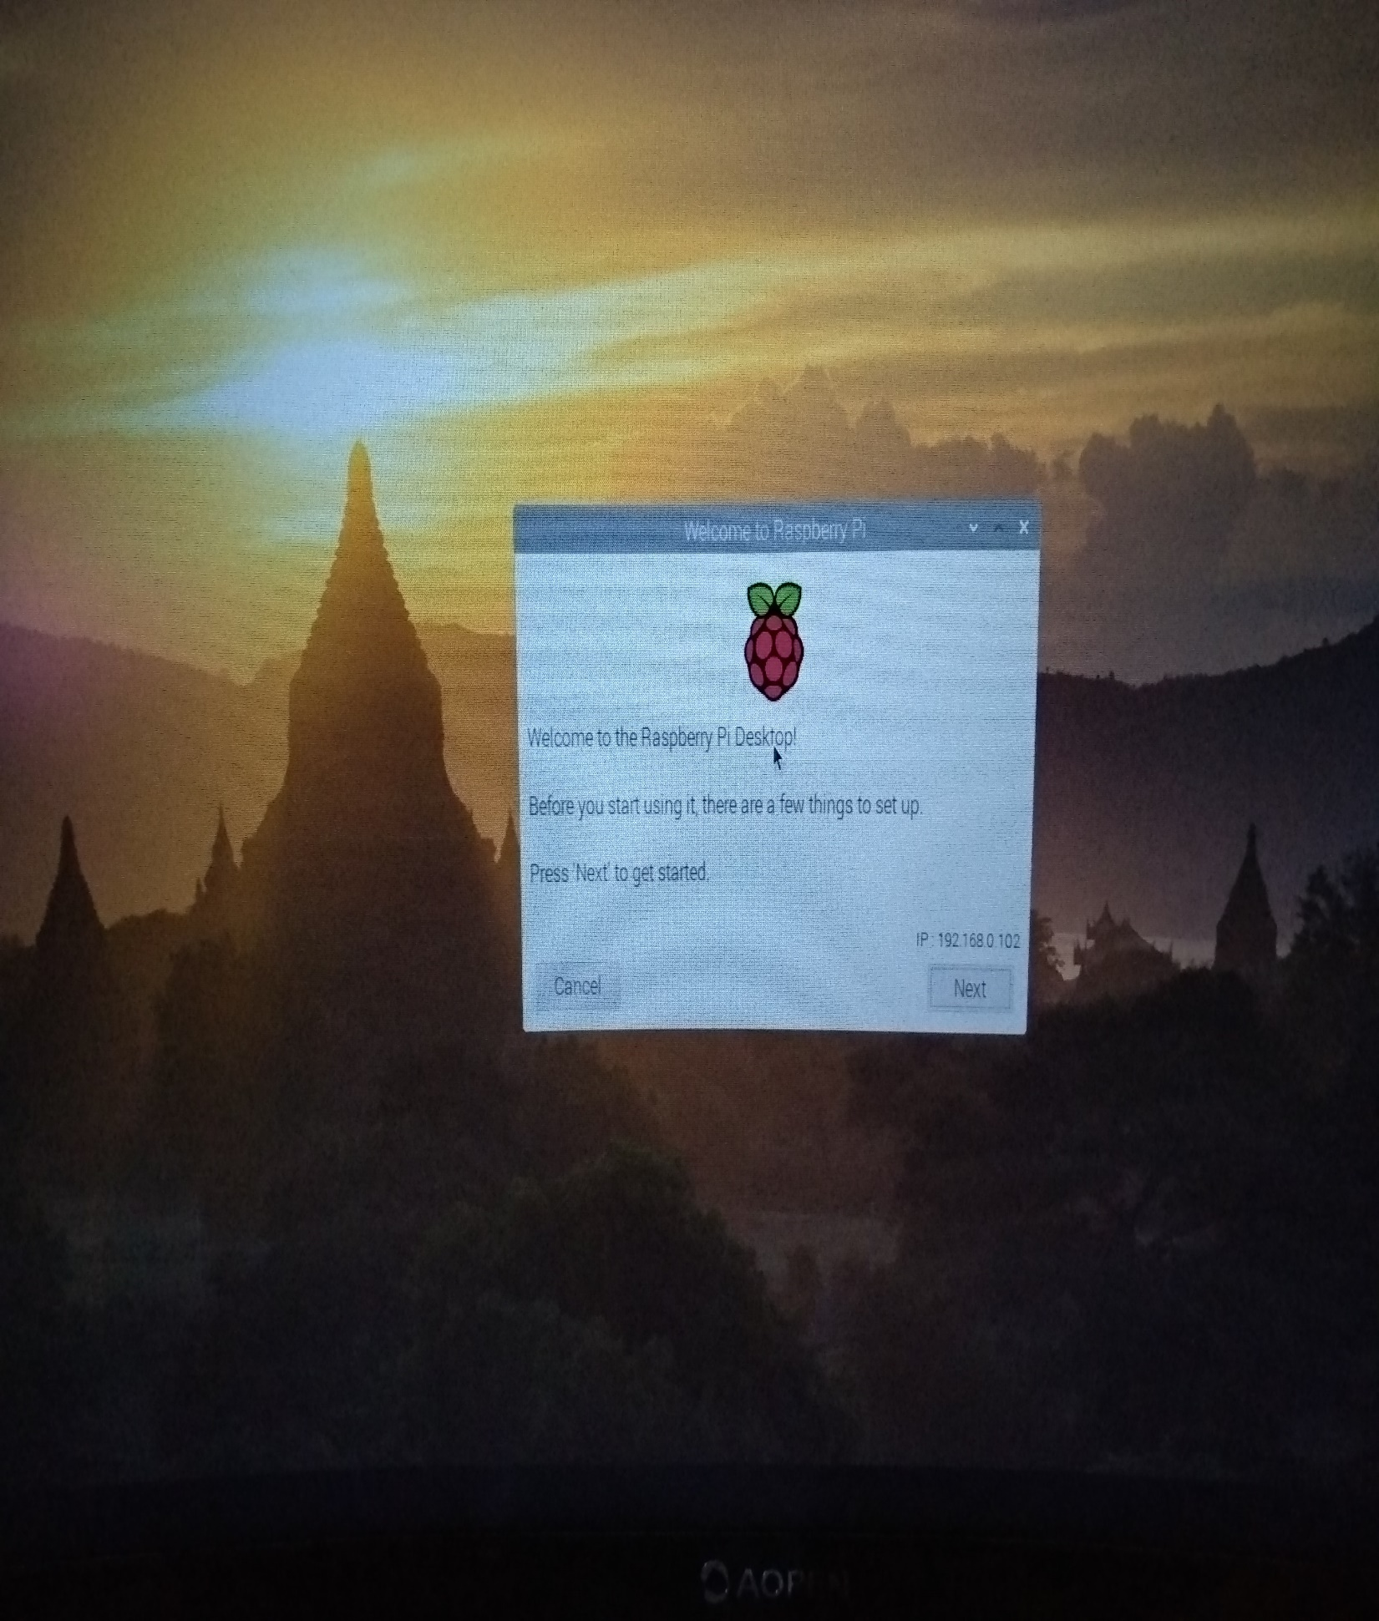

- Final image of prepared module

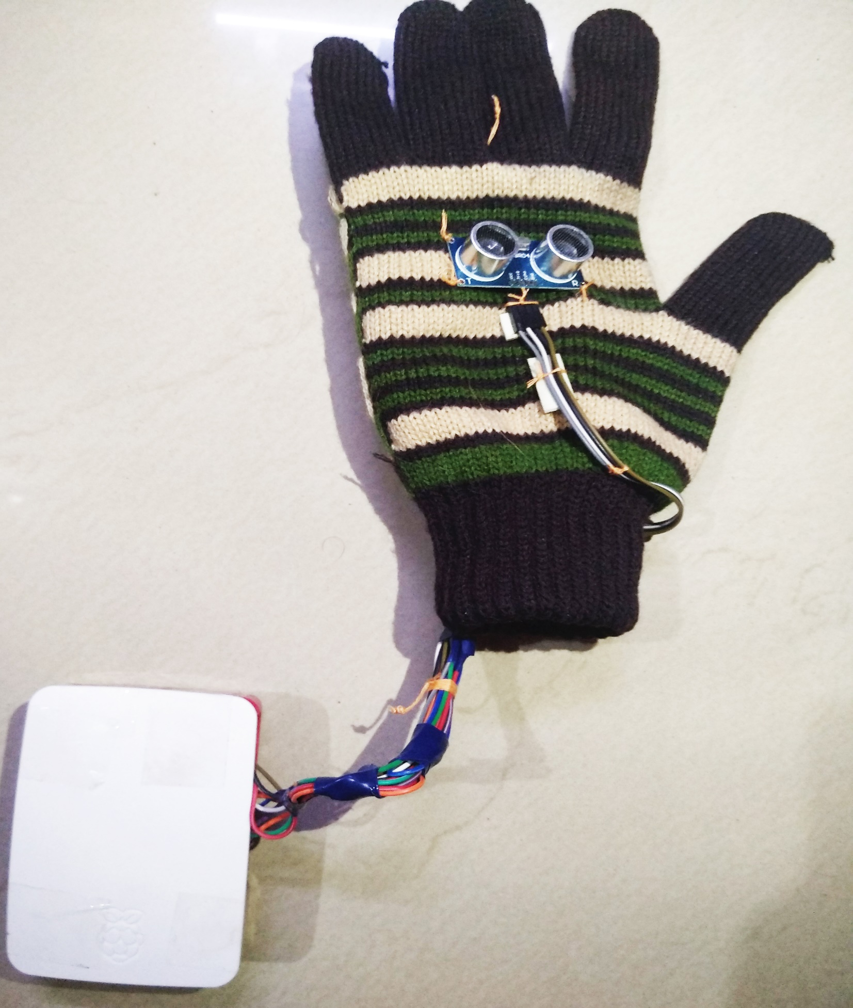

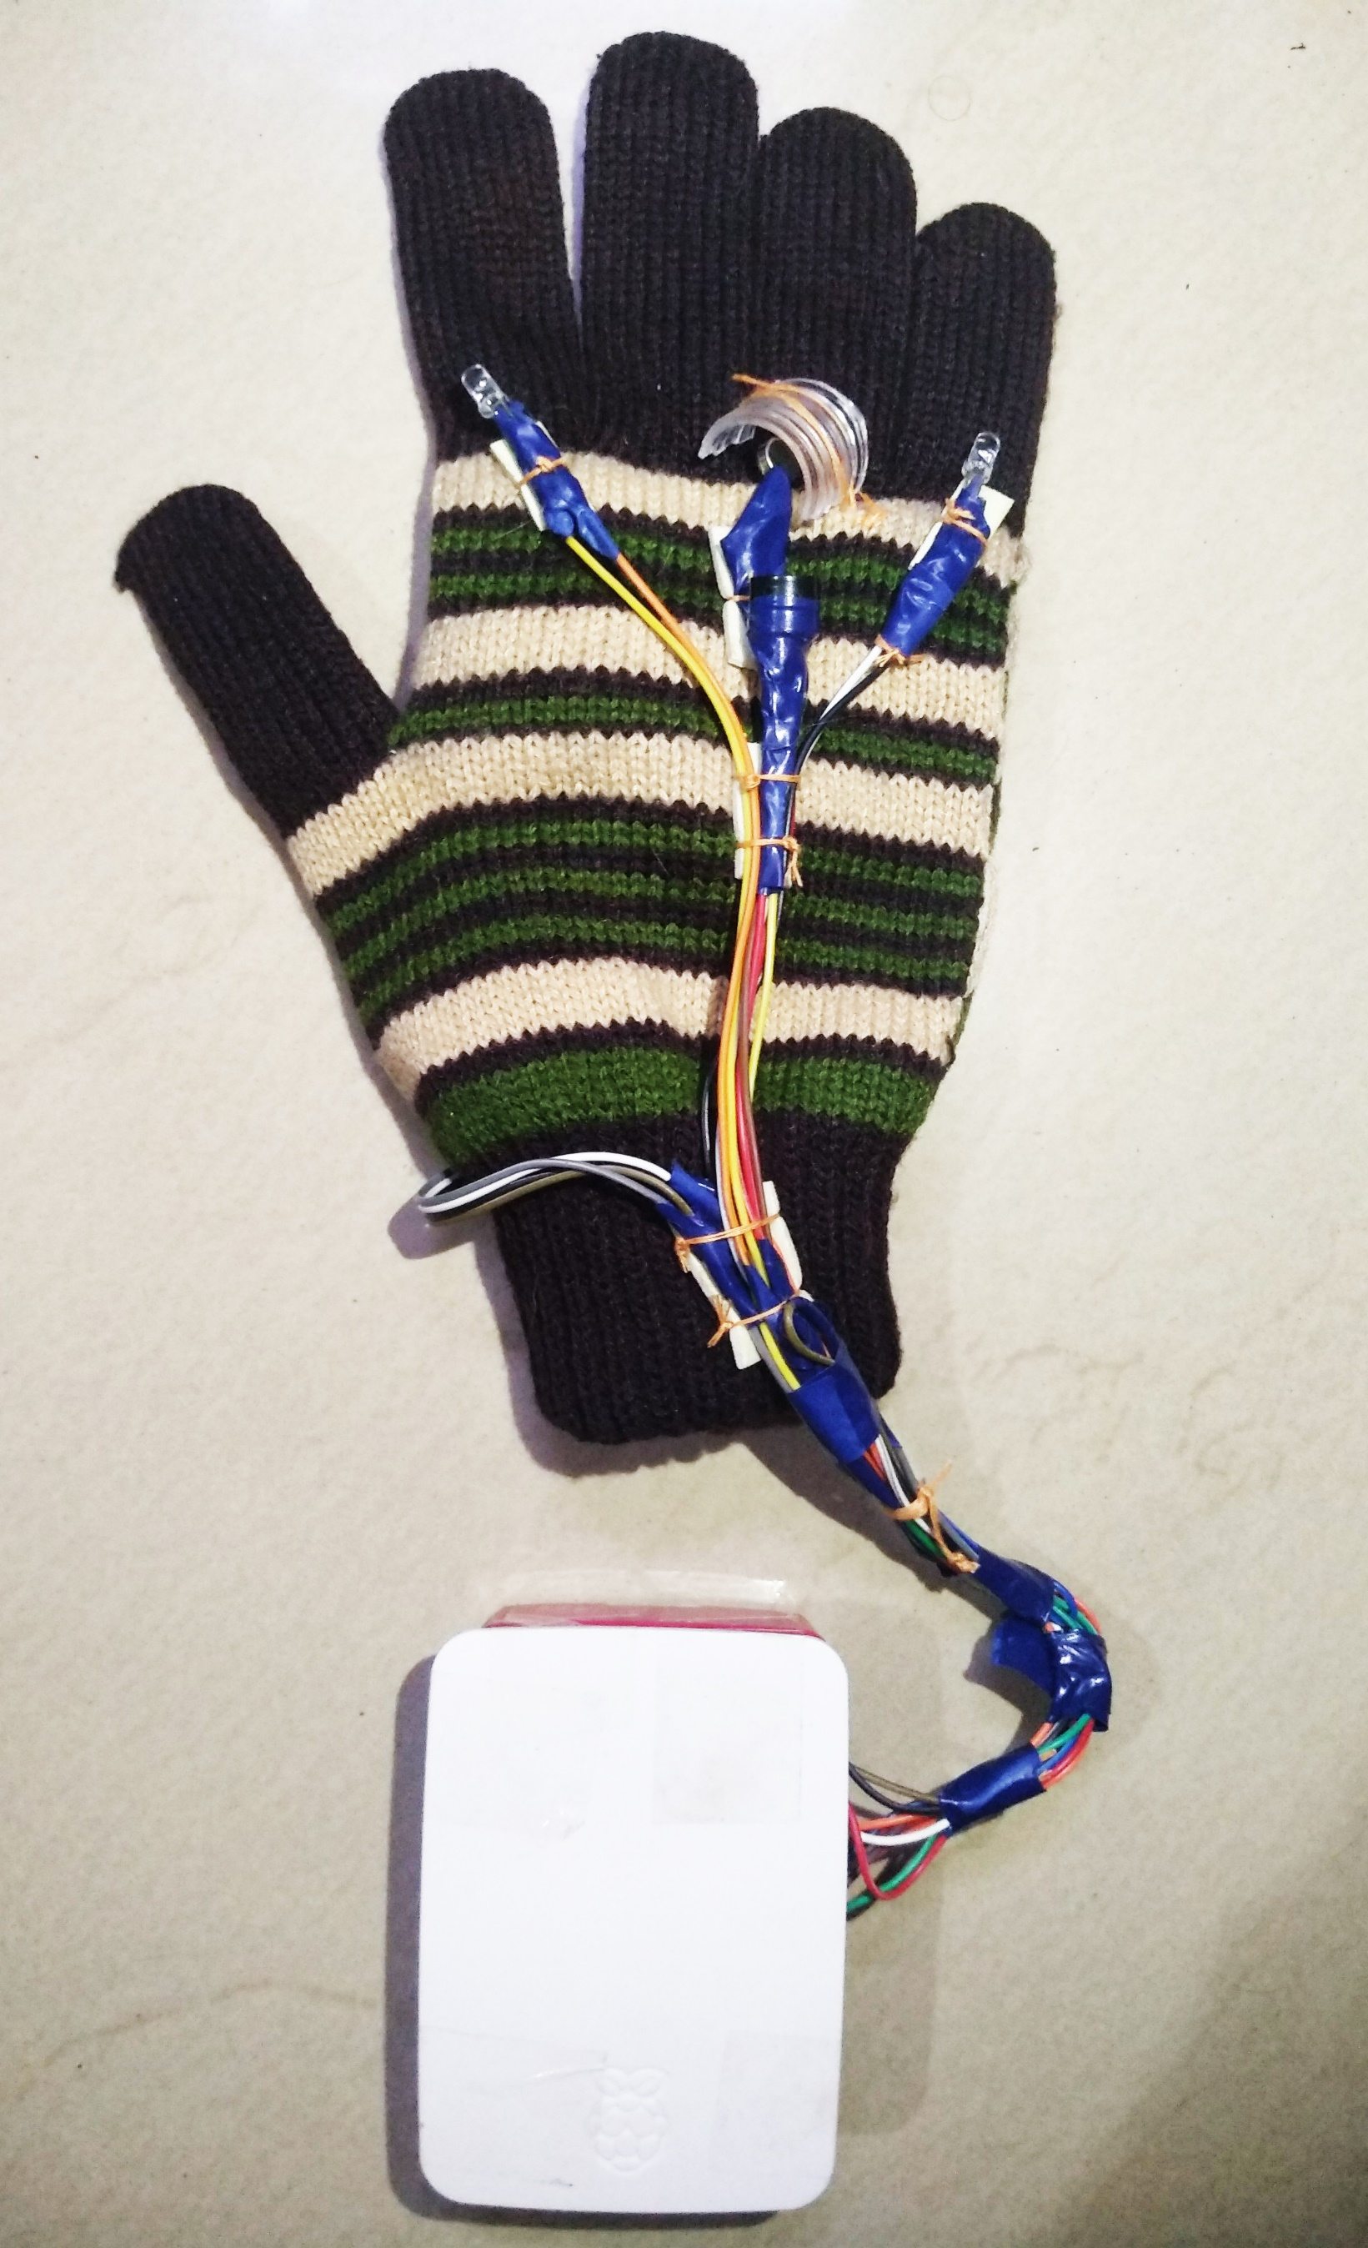
Output image of program

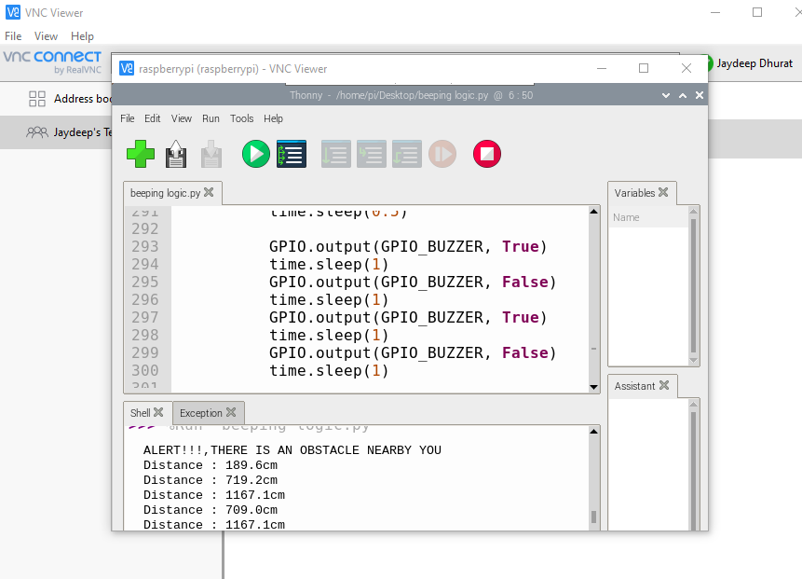

e) Timeline of Progress Reports
Task Name | Planned Start Date | Planned Finish Date | Planned  Duration (in days) | Actual Start Date | Actual Finish Date | Signature  of the Guide
Analysis | Monday,  February 1,  2021 | Wednesday,  February 10,  2021 | 8 | 1st Feb, 2021 | 10th Feb, 2021
Defining Problem Statement of the Project and gathering Information | Monday, February 1,  2021 | Thursday, February 4,  2021 | 4 | 2nd Feb, 2021 | 4th Feb, 2021
Document Current System | Tuesday, February 9,  2021 | Wednesday, February 10,  2021 | 2 | 5th Feb, 2021 | 7th Feb, 2021
Analysis Complete | Wednesday,  February  10, 2021 | Wednesday,  February 10,  2021 | 0 | 10th Feb, 2021 | 10th Feb, 2021
Design | Thursday,  February 11, 2021 | Thursday, March 4,  2021 | 16 | 11th Feb, 2021 | 4th March, 2021
Design Database | Thursday,  February  11, 2021 | Tuesday,  February 16,  2021 | 4 | 11th Feb, 2021 | 13th Feb, 2021
Software Design | Wednesday, February 17, 2021 | Wednesday, February 24,  2021 | 5 | 17th Feb, 2021 | 20th Feb, 2021

Task Name | Planned Start Date | Planned Finish Date | Planned Duration (in days) | Actual Start Date | Actual Finish Date | Signature of the Guide
Interface Design | Wednesday, February  24, 2021 | Thursday, February 25,  2021 | 2 | 21st Feb, 2021 | 22nd Feb, 2021
Create Design Specification | Friday,  February 26, 2021 | Thursday,  March 4,  2021 | 5 | 24th Feb, 2021 | 1st Mar, 2021
Design Complete | Thursday, March 4,  2021 | Thursday, March 4,  2021 | 0 | 4th March, 2021 | 4th Mar, 2021
Development | Thursday,  February 11, 2021 | Monday,  March 15,  2021 | 21 | 11th Feb, 2021 | 15th Mar, 2021
Develop System Module | Thursday,  February 11, 2021 | Friday, February 26,  2021 | 11 | 11th Feb, 2021 | 21st Feb, 2021
Integrate System Module | Monday,  March 1,  2021 | Tuesday,  March 9,  2021 | 7 | 1st Mar, 2021 | 6th Mar, 2021
Perform Initial Testing | Wednesday, March 10,  2021 | Monday, March 15,  2021 | 3 | 10th Mar, 2021 | 14th Mar, 2021
Development Complete | Monday, March 15,  2021 | Monday, March 15,  2021 | 0 | 15th Mar, 2021 | 15th Mar, 2021
Testing | Monday,  March 1,  2021 | Thursday,  March 25,  2021 | 17 | 1st Mar, 2021 | 25th Mar, 2021

Task Name | Planned Start Date | Planned Finish Date | Planned Duration (in days) | Actual Start Date | Actual Finish Date | Signature of the Guide
Perform System Testing | Monday, March 1,  2021 | Wednesday, March 10,  2021 | 8 | 2nd Mar, 2021 | 9th Mar, 2021
Documenting Issues Found | Friday,  March 12,  2021 | Friday,  March 19,  2021 | 6 | 12th Mar, 2021 | 18th Mar, 2021
Correcting/Resolving Issues Found | Monday, March 22,  2021 | Wednesday, March 24,  2021 | 3 | 22nd Mar, 2021 | 23rd Mar, 2021
Testing Complete | Wednesday, March 24,  2021 | Wednesday, March 24,  2021 | 0 | 24th Mar, 2021 | 24th Mar, 2021
Implementation | Thursday, March 25,  2021 | Tuesday, March 30,  2021 | 4 | 25th Mar, 2021 | 30th Mar,2021
On-Site/On-Campus Installation | Thursday,  March 25,  2021 | Monday,  March 29,  2021 | 3 | 25th Mar, 2021 | 28th Mar, 2021
Demonstration | Tuesday, March 30,  2021 | Tuesday, March 30,  2021 | 1 | 30th Mar, 2021 | 30th Mar,2021

Chapter 7

7) Conclusion and future work
b) Bibliography

As IoT begins to make its mark on the tech industry and revolutionize not only consumer goods but virtually every aspect of human life (author suggests things from cars to street lights to seaports will eventually be “smart”), the importance of IoT, or IoE, lies, as the author points out, in the sensors and cloud computing inherent in the technology

The IoT as described by the authors is the “third wave” of product revolution due to information technology. The ubiquitous connectivity of smart devices has two unique functions: 1) to allow the product to transmit information wirelessly to outside parties (i.e. the manufacturer, user, other products, etc.); and 2) the product cloud – allowing some of the product to exist outside of the physical instrument. Connected devices, essentially products with built-in computers with wireless connectivity, require manufacturers to develop new technology infrastructures, known as “technology stacks.” According to the authors, a stack is comprised of, “modified hardware, software applications, an operating system embedded in the product…network communications to support connectivity, and a product cloud containing the product-data database, a platform for building software applications, a rules engine and analytics platform, and smart product applications that are not embedded in the product.”

These smart devices have three purposes, as argued by the authors: 1) to monitor the product’s condition, external environment, its operation and usage through the use of sensors, and to enable alerts/notify of changes; 2) to control and personalize user interaction with the product in novel ways; 3) to optimize the product operation and use in order to enhance the product and to allow predictive diagnostics, service, and repair. Combining these three factors of the “smart” device allows autonomous product operation, self-coordination of operation.

References:
a) Wikipedia Documentaries
b) Pypi.org website for different python libraries which are used in project
c) Raspberry-Pi Official website & their research papers
d) Newly released documentation & architecture of Raspberry-Pi Model 3B +

THANK YOU!

